**CHAPTER**

**2**

**UNMANNED WEAPON SYSTEM: A DATA SCIENCE AND ARTIFICIAL INTELLIGENCE**

**APPROACH FOR FUTURE WARFARE**

*Fazliezawati Abdullah and Dayang Norhayati Abang Jawawi*

* 1. **INTRODUCTION**

Military organizations are involved in violent conflicts against internal and external threats. These conflicts can cause the killing and wound of thousands of personnel and civilians. Military roles and responsibilities are to defend the nation's sovereignty, territorial integrity and national interest by maintaining peace and preparing for armed conflict. After many decades, the weapon systems used have been upgraded along with technological advancement. However, there are still acquired human supervision and intervention. Therefore, many military organizations are ready to embark on a new direction of future warfare by looking at an unveiled cutting-edge integrated weapon system that utilizes advanced augmented reality technologies. The system uses Artificial Intelligence (AI) to detect, identify and destroy the targets without human intervention. The use of machines can reduce the risk of casualties in a complex and dangerous mission. Fewer people are required for a specific mission, which will minimize the use of resources. The unmanned weapon system can also expand the battlefield by allowing the military personnel to reach previously inaccessible areas. The system will be one of the long-term Returns of Investment (ROI) planned by the countries for a better future. The structure of the proposed Unmanned Weapon System (UWS) is shown in **Figure 2.1**.

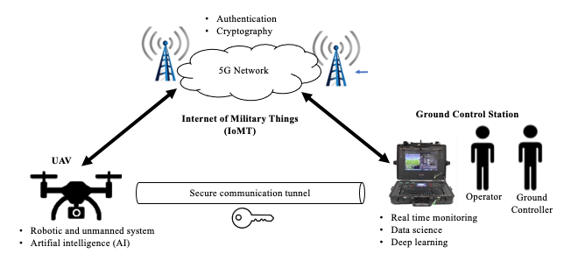

**Figure 2.1** Structure of the Proposed UWS

The objectives of the UWS's development are to:

* Use the latest technologies to automate the current operating system for the unmanned weapon system.
* Improve the efficiency of an unmanned weapon system.
* Achieve greater speed, accuracy, persistence and coordination in the operation area and battlefield.
* Reduce the risk of human intervention and minimize resources.
* Achieve command and control in making a critical decision effectively.
* Strengthen the military operation to protect the nation's sovereignty.

War and technology have always been linked very closely. Indeed, without technology, there would probably have been no war. However, under the circumstances, war is still happening. Nations need to protect their sovereignty, enhance their technological superiority and show their military power. The development of weapons has always helped determine tactics, and the tactics, in turn, helped determine the organization, operations, strategy and command and control systems. All these were driven by the technology in use that drove it along. The quest for technological superiority is eternal.

Previously the distances over which operations could be conducted depended on the speed with which individuals, units and machines moved about. Thus, the current and future wars minimize the use of these resources by implementing augmented and unmanned machines. The idea is to reduce human intervention and increase the safety of military personnel. A very important effect of such developing technology was to enable war to spread into environments that used to be inaccessible to it, from the land to the sea and from the surface into the air. There is no problem with losing the line of sight of the target nor the precise image and video of the target. Thus, the nations will achieve greater speed and increase efficiency, accuracy, persistence and coordination in the operation area and battlefield. However, the more advanced the technology, the more complex it was and the greater difficulties involved in its development. And these difficulties, in turn, translated into time and money.

The advancement of technology will increase speed in a multitude of disciplines. AI, machine learning, data science and data analytics, the Internet of Things (IoT), sensors, communications and robotics are presumably the key technologies that deserve the most attention. The most innovative thinking is about using these multitudes of disciplines to develop a superpower weapon. The current and future battlefield environment no longer requires a face-to-face conventional war. It requires a system that can integrate real-time input or data from various sources such as UAVs or drones, radar, satellites and sensors. AI technologies such as machine learning and deep learning are required to transform or analyze the data into valuable information for the commander's command and control decision-making process. Therefore, the UWS is proposed in order to enhance the requisition planning of military weapon systems for a better future.

UWS aims to conduct complex surveillance and security maneuver, detect and identify potential threats, and automate the weapon system's operation. The primary functions to be provided by the system are listed below:

* Sensors that allow the system to gather and identify the data.
* A suite of computer hardware and software allows the system to interpret data from the sensor and transform it into a plan and action by using a microprocessor, computer chips, sensing software, and control software that acts like a system's brain.
* Communication technology and human-machine interfaces (Internet of Military Things and 5G) allow the system to interact between the agents, whether machines or humans.
* The actuator allows the system to execute its operating environment or battlefield actions.

Data science and AI technology play an important role in developing UWS. Data science is a computing sub-discipline field that uses scientific methods, processes, algorithms and systems to extract data across various application domains. Data science is required to allow AI technologies to interpret data from the sensors and transform it into a plan and action. Without data science, the action taken may not be accurate and invaluable.

This chapter is organized by firstly presenting related work in Section 2.2. Section 2.3 describes data science as a combination of the sub-discipline, while Section 1.4 explains the result and discussion. Section 1.5 of this chapter provides the conclusion drawn from the study.

**2.2 RELATED WORKS**

The proposed UWS will extend the operation to deterrence, where the augmented reality system can deny and attack the threats when forced. Thus, the three concepts behind the UWS are:

* **Detect**; optimize intelligence, surveillance and reconnaissance (ISR) to detect the threats. Information will be gathered from the various UWS operations and radar sensors owned by the military and other government agencies to optimize detection.
* **Ident**; tracking and information delivery networks through ISR to identify threats. With an AI capability, information will be processed and analyzed for decision-making action by commanders.
* **Deter**; implement barrier prevention by demonstrating the presence of UWS in the area of ​​operations at all times and coordinating a joint operation as a surface intervention in deep focus areas. If the situation gets worse, fire will be released.

A drone or UAV, according to the definition by ICAO, is an aircraft operated without a human on board. They again define UAS as being made up of components such as a drone, the ground controller and the communication system between the two. Drone and UAV technology was discovered way back in World War I and II, and the development has changed over these periods to modern conventional war. In the military, this technology has the potential to reduce costs and risks to military personnel as it can be used in lethal surveillance and targeted killings with minimum human intervention. The system used in military ISR is usually directly linked to targeted strikes for deterrence purposes. AI plays a key role in military drones or UAVs, which has made the system able to differentiate between civilians and targets. The discourse is on the ability of the AI environment to be able to execute tasks with ethical considerations. Thus, data science plays an important role in creating AI technology.

The concept of delivering precision-guided weapons with drones in the military has also been adopted to support humanitarian missions such as earthquakes and other natural disasters like floods and fire. Land border security is currently an important aspect where drones are used to do ISR on illegal activities along the border. This technology has played an important part in globalization and being at the front of disrupting change. Military drones have played a crucial role in shaping many sectors to adopt the technology. Since the demand for it is increasing in the military, more opportunities for usage could be explored in varying fields to derive the benefits of its technology.

However, there could be chances that the weaponize drone’s military concept for lethal operations has been extended with bad intentions to achieve malicious objectives. A system that is not properly secured during operation can be hacked by irresponsible individuals and may utilize drones for terror attacks. The regulatory regimes are necessary to realize drones' full potential while keeping up civilians' safety and privacy. There are also a few related projects on autonomous or unmanned drones and UAVs developed domestically and abroad for military operation. Their capabilities vary from monitoring and observation to ISR and also a weapon system.

**2.2.1 AIMS - C4 by CarteNav**

CarteNav was established in 2002 based in Canada. The company develop ISR mission software for security, safety and environmental operations. AIMS-C4 is a system that allows real-time communication and data sharing between operators, analysts and decision-makers. It offers UAS operators’ industry-leading technology previously only available for piloted aircraft. It enhanced situational awareness features, including vision augmented reality overlays, in-video measurement tools, perimeter mapping and moving target indication. It was developed based on the CarteNav software, the international leader in developing ISR mission software. The software equips maritime, land and air mission operators to execute their mission with maximum effectiveness. AIMS can provide highly accurate, near-real-time maps of the current situation to planners, and without it, it is impossible to complete the mission.

AIMS is equipped with multi-sensor control, geo-referenced moving maps, evidence reporting, signal intelligence and custom mapping. Its plugin architecture allows for the mission flexibility of any sensor integrated on the chosen platform. It also has interactive geo-referenced moving maps for planning, executing, and reviewing ISR mission data and integrated control of primary and secondary mission sensors, including radar. The ISR data can then be shared in real-time with rapid report generation. Augmented reality tactical overlay displays Point of Interest (POI) markers, street labels, in-video measurement tools, perimeter mapping and Areas of Interest on top of live sensor video to enable maximum awareness.

The moving target indicator enables operators to harness AI to identify moving targets or small objects automatically. The system can also increase the visibility of difficult targets and track their historical movement. AIMS goes beyond intuitive on-screen buttons and physical controllers. The multi-lock tracking automatically keeps the cameras, radars, and sensors focused on the target of interest. It selects target tracks from radar and signal intelligence data integrations and slew to the selected track to update position. The system has a capacity for multi-mission where it detects and tracks multiple targets across large areas directly in the local operating picture. By having this, it allows for compact interfaces with a minimum sensor operating crew. Whether on sea, land or air, AIMS makes multi-station operator networks easy with real-time mission data sharing and client interfacing. Operators can be located in the command-and-control station, which enables efficient dissemination of mission information and rapid decision making.

**2.2.2 KARGU by STM**

STM was established in 1991 by the decree of the Turkey Defense Industry Executive Committee to provide project management, system engineering, technology transfer, technical and logistical support and consultancy services. The company operates in various fields, including military naval platforms, cyber security, UAV system, radar and satellite technologies, and command and control systems. KARGU is a rotary-wing attack drone designed locally in 2020 to perform fully autonomous navigation and provide tactical ISR and precision strike capabilities. It is a 15-pound multi-copter with a top speed of about 90 mph and an endurance of half an hour. The platform is designed for both ISR and striking targets outside the line of sight with high accuracy and can be operated autonomously. The platform can detect and strike static or mobile targets with high precision during day and night conditions. The system consists of the rotary-wing attack drone and ground control unit.

KARGU uses machine learning algorithms embedded on the platform enabling it to operate autonomously and manually controlled by operators from up to six miles away. It is also capable of producing real-time image processing and deep learning algorithms. When a target is spotted, the drone locks on a target with an explosive charge. The attack comes in three varieties: (1) An explosive/fragmentation version for personnel and light vehicles, (2) A thermobaric version to destroy buildings and bunkers, and (3) A shaped charge for heavy armor vehicles. KARGU can return safely to the operator for re-use if no target is found. The drone features light detection and ranging (LIDAR), a daylight camera and infra-red imaging. It is highly autonomous, can fly a route, and uses deep learning algorithms to locate, track, and identify targets without human assistance.

The newer version of KARGU can allegedly autonomously track and kill human targets based on facial recognition and AI. STM company is also developing the swarm drone’s operation, which allows a group of drones to coordinate their actions so that they can search efficiently and carry out attacks simultaneously against different targets.

**2.2.2 Caihong-5 (CH-5) By China Aerospace Science and Technology Corporation (CASC)**

CASC, one of the Fortune Global firms, is a large state-owned enterprise group with its own independent intellectual properties and outstanding innovative capabilities. It was formally founded in Jul 1999. CASC is a leading force in China's space industry, mainly engaged in researching, designing, manufacturing, testing, and launching space products, including drones and UAVs. CH-5 or Rainbow was first unveiled to the public in 2017. It is the name of a series of Chinese Unmanned Combat Aerial Vehicles (UCAV), meaning it can carry and deliver with a level of precision munition of various types. It has had many variants base series designation since the first version was introduced in 2011. The CH-5 is an aircraft inherently designed with an autonomous hunter-killer capability to cover a variety of over-battlefield and long-endurance performances. It was developed to operate near active ground elements through a broad array of air-to-ground ordnance and munitions options. It is reported that the newest variant has been fitted with a heavy fuel engine and extends the endurance up to 60 hours with a range of over 10,000 km. It can conduct surveillance of ground targets and target areas, assess environmental threat levels and enemy strength and tracks enemy movement. It can also conduct aerial bombing of ground targets through guns, bombs, missiles, and rockets.

**2.3 DATA SCIENCE AS A COMBINATION OF COMPUTING SUB-DISCIPLINE**

Data science has been a hot topic among professionals and organizations recently. Data is becoming an asset to many organizations. The need for storage grew multifold as we entered the big data. Since 2010, the major focus has been on building an infrastructure to store these valuable big data, which can be accessed and processed to draw organizational insights. Big data is categorized into five characteristics, as shown in Figure 2.2.

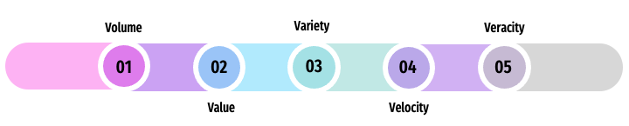

**Figure 2.2** Characteristics of Big Data

As the storage part has been taken care of, the current focus now shifted towards how to process the data and use the data in order to solve the problem, produce solutions and fit the organization's requirements. The data has many forms, and new data sources are larger, complex, and generating quickly. Traditional data processing methods and tools cannot manage these types of data sets. This big data requires architectures and tools for capturing, maintaining, processing, analyzing and communicating to find solutions. Therefore, we need data science to complete the job.

Oracle.com describes data science as preparing data for analysis, including cleansing, aggregating and manipulating the data to perform advanced data analysis. TechTarget.com describes data science as a field of applying advanced analytics techniques and scientific principles to extract valuable information from data for decision making, strategic planning and other uses. Whereas, DataRobot.com explains data science as a field of study that combines domain expertise, programming skills and knowledge of mathematics and statistics to extract meaningful insights from data. The main premise of data science is its ability to transform raw data into valuable information.

Data science plays an important role in all aspects of business operations and strategies. It is all about a systematic process used to analyze, visualize and model large amounts of data. A data science process helps UWS use the tools to find patterns, extract data and convert information to actionable insights that can be meaningful. In developing the UWS, data science involves in predictive modelling, pattern recognition, anomaly detection, classification, categorization and sentiment analysis. The capabilities requirements of UWS can be described as follows:

* **Unmanned** - The system can be operated with various degrees of autonomy or operated remotely by the ground controllers (less human intervention).
* **Sophisticated and persistent surveillance** - Drones are equipped with a high definition, live-feed video camera, thermal infrared video cameras, heat sensors and radar. Therefore, it can record video or still images day and night and upload them into the data processing platform to be analyzed.
* **Laser range finders** - The unmanned weapon system can determine the distance to a particular object or target of interest.
* **Object tracking** - It consists of processing the video in real time so that any moving within the field of view can be detected.
* **Image annotation for computer vision** - The drones will interpret and interact with their surroundings, including terrain, buildings and trees.
* **Strike** - The drone is capable of carrying payloads to perform airstrikes.

Hence, the data science process will help discover the hidden patterns of structured and unstructured raw data to fulfil the requirement of UWS development. There are seven processes identified as per Figure 2.3.

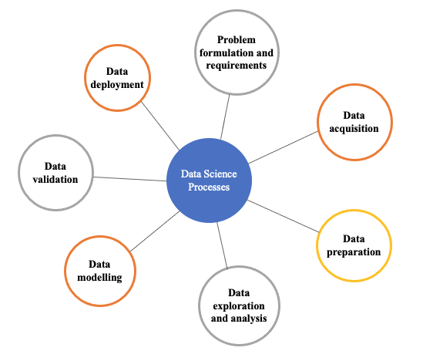

**Figure 2.3** Data Science Processes (*Resource:* Silaparasetty, V. (2020))

**2.3.1 Problem Formulation and Requirements**

Problem formulation in UWS development is the process of devising a data science solution to its requirements. This process is important for the entire development. In terms of data science, a problem statement is always thought of in mathematical terms. Understanding the goals and expectations is crucial as the information provided is the basis for analysis. The UWS objectives need to be clear, and the problem that the team will be facing must be discovered. Other than that, the team also must describe the resources available in terms of infrastructure, pre-requisite features, transactions and results. The potential benefits and risks must be outlined to make military organizations worth pursuing this project. Expected benefits must be realistic and attainable from the data point of view and duration. Then, after the goals and expectations are clear, teams need to translate them into data goals to understand the scope of the project development. The problem statement is constructed to describe the problem, why solving the problem is important, and starting point to begin solving it. The success metric such as model assessment and benchmarks can be used to measure achievement.

**2.3.2 Data Acquisition**

Drones are equipped with a high definition, live-feed video camera, thermal infrared video cameras, sensors and radar. The role of this equipment is to acquire high-spatial real-time video and still images that can help in data analysis of the objects and targets of interest. Other than that, a dataset can be acquired from a laser range finder to determine the distance.

**2.3.3 Data Preparation**

Data acquisition is often inconsistent and duplicated. It has to go through data cleaning before going further and analyzing it. Only valuable data is required for the analysis and decision-making process. Data can be messy if it has not been appropriately maintained, which will lead to errors and inaccurate for commanders. The data can be transformed and modified using available data integration tools.

**2.3.4 Data Exploration and Analysis**

Data exploration refers to the initial steps in data analysis. Teams can use data visualization and statistical techniques to describe dataset characterizations such as size, quantity, and accuracy to understand the nature of data (objects and targets of interest). This process makes deeper analysis more accessible because it can help target future searches and begin the process of excluding irrelevant data points that may turn up no results.

**2.3.5 Data Modelling**

Data modelling identifies the model that best fits the UWS requirements. It is a process for defining and ordering data for use and analysis by certain processes. The goal is to produce high-quality, consistent, structured data for the UWS and achieve consistent decision-making results. It trains the models on the training dataset and test. In the end, the best-performing model will be selected.

**2.3.6 Data Validation**

The following process is data validation. It refers to the process of ensuring the accuracy and quality of data by building several checks into a system to ensure the logical consistency of the input and stored data. In UWS, data is entered without or with minimum human supervision. Therefore, it is necessary to ensure that the data received is correct and meets the desired quality standards. Types of the data validation procedures in UWS include (1) Data type check, (2) Code check, (3) Range check, (4) Consistency check, and (5) Uniqueness check.

**2.3.7 Data Deployment**

The concept of deployment in data science for UWS development refers to the application of a model for prediction using new data. The purpose of the model is to increase knowledge of the data. However, it still needs to be organized and presented in a way that operators and commanders can use it. The deployment phase can be complex as implementing a repeatable data science process.

Analytics tools are types of application software that retrieve data from one or more systems and combine it in a data warehouse to be reviewed and analyzed. Numerous tools are available to use in the analytics process, such as:

* Data platforms and analytics engines such as Apache Spark, Hadoop and NoSQL databases.
* A programming language such as Python, R, Scala and SQL.
* Statistical analysis tools like SAS, Power BI and SPSS.
* Jupyter Notebook, a web application for sharing documents with code, equations and other information.

Data visualization tools and libraries such as Tableau, D3.js and Matplotlib

**2.4 RESULT AND DISCUSSION**

**2.4.1 Disruptive Technologies**

New and intelligent technology is being released at a fast pace. Disruptive technology is an innovation that considerably changes how existing markets, industries, individuals and organization’s function. It replaces well-established systems, products or even habits because of its obviously superior attributes. According to Gartner, 12 disruptive technologies and trends that act as force multipliers to a digital business and innovation over the next three to five years are listed in **Figure 2.4**.

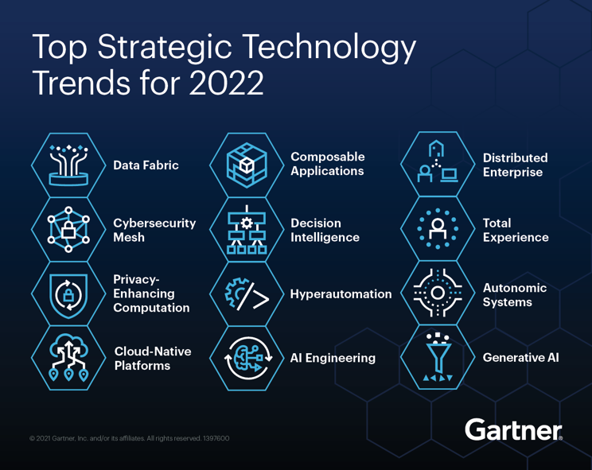

**Figure 2.4** Top Disruptive Technology Trends for 2022

Disruptive technologies that enable the development of UWS are as follows:

* **Robotic Process Automation (RPA)** - Military plans to utilize various forms of automation to increase efficiency, save time and reduce costs in the process. RPA utilizes drones to gather data on the ways that it interacts with UWS applications and then emulate that behaviour with minimal human involvement.
* **Machine Learning** - Machine learning is the method by which technology can analyse data and then use that information to draw conclusions based on the recognition of patterns. Data science uses machine learning to recognise relevant data patterns and make decisions with a high degree of accuracy.
* **Natural Language Processing (NLP)** - NLP is used to bridge the gap between computers and humans. The goal of NLP is to create UWS that can read or hear human languages and process that data in a meaningful way. It allows technology to interface with that data in new and disruptive ways.
* **Augmented Analysis** - Augmented analytics can create valuable and real-time insight from drone data sources. Traditional analytics in the form of reports and dashboards are rigid and manually structured. Whereas augmented analytics turns on what operators and commanders will do with data. It is a learning model development that enables rapid and accurate forecasting and fast decision-making.
* **Blockchain** - The digital landscape is more transparent but in a secure way. Blockchain technology has led to the rise of cryptographies that will be used in UWS development.

**2.4.2 Incorporating Data Science in the AI Environment for the Development of UWS**

Data science relies heavily on AI to get a UWS system that can mimic human behavior in some way. Data scientists apply the algorithms to numbers, text, images, video, audio and more to produce augmented systems to perform tasks that ordinarily require human intelligence. Figure 5 explains the relationship between AI, machine learning, artificial neural networks (ANN) and deep learning that has been implemented in developing UWS. Figure 2.6 illustrates the connection between Data Science and AI.

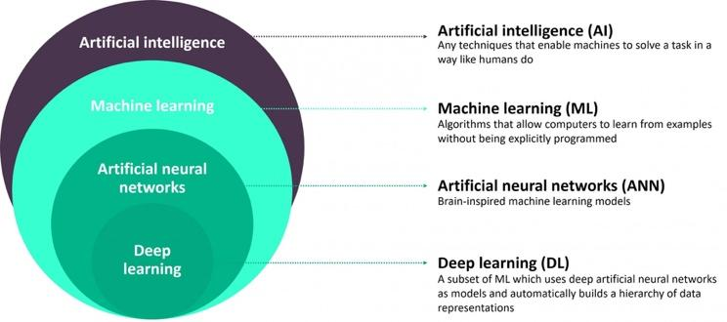

**Figure 2.5** Relationship between AI, ML, ANN and DL (*Source:* Khamis, A. (2019)).

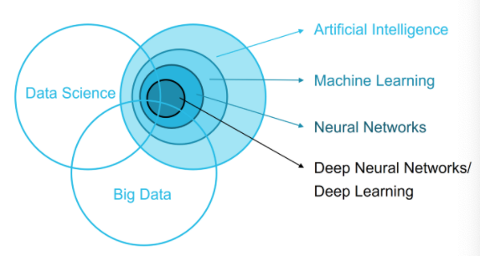

**Figure 2.6** Relationship between AI, Big Data and Data Science, Karen (2019)

There is a need for a systematic procedure for data science processes in the AI environment for UWS. To create successful models for UWS, involvement from military personnel is required to help collect the relevant data and understand the UWS target requirements. The importance of the problem and challenges of the existing system needs to be understood. Different relevant independent and dependent variables represent the model response for the drone itself, such as the sensors and live feed video camera.

The UWS is part of a computational model that mimics how the human brain analyzes and processes the information needed. In AI model development, it is important to collect relevant and comprehensive data captured by the drone. The volume may depend on the complexity of the data. AI recognizes patterns from the vast amounts of quality data (objects and targets), providing insights, predicting outcomes and also making decisions. At the same time, machine learning is a branch of AI where a class of data-driven algorithms enables software applications to become highly accurate in predicting outcomes. It utilizes advanced statistical techniques in which algorithms learn about data sets and then look for patterns, anomalies or insights in them. Machine learning develops algorithms that can receive input data from drones and leverage statistical models to predict output in UWS. The processes involved data science (predictive modelling and data mining). Data science demands one to search through the data to identify patterns and adjust the program accordingly. Data science uses computer science disciplines like mathematics and statistics and incorporates techniques like data mining, data analysis, visualization, data modelling and machine learning.

The use of deep learning enables systems to solve more complex problems. Deep learning is also a more advanced offshoot of machine learning that primarily uses artificial neural networks to analyse large data sets in UWS. Predictive models are another core in data science technology. Data scientists create them by running machine learning, data mining or statistical algorithms against data sets to predict scenarios and likely outcomes or behaviour. In predictive modelling and other advanced analytics applications, data sampling is often done to analyse a representative subset of data, a data mining technique designed to make the analytics process more manageable and less time-consuming.

**2.5 CONCLUSION**

In the future battlefield environment, preserving air superiority is very important, and the UWS is one of the military solutions. The concept is widely used by other developed countries. Other than reducing human intervention on the battlefield, deployment of UWS is sure will increase the efficiency and effectiveness of military operations. Humanity and technology are intrinsically linked. The evolution of technology has always impacted how we work, think and interact with one another. It disrupts and improves upon traditional models of virtually all human practices in the process, and that trend continues at an ever-accelerating pace. Data science comprises a set of tools that intend to improve processes and decisions in the development of UWS. The data science, AI and machine learning implementation also have reduced the number of challenges in developing UWS. Combining these advanced technologies will allow UWS to operate in highly contested airspace in pre-emptive and reactive roles.

**ACKNOWLEDGEMENT**

The authors fully acknowledge Universiti Teknologi Malaysia assistance via UTM-HR Grant Vote No. 08G67 which has made this research possible. We also thank to the Malaysian Armed Forces (MAF) for scholarship funding of this Master's Degree study.

**REFERENCES**

Bousquet, A. (2018)

"The Eye of War: Military Perception from the Telescope to the Drone". *Minnesota Press.*

CarteNav Team (May 27, 2020)

"Beyond Search & Rescue: Delivers Multiple ISR Missions".

Creveld, M.V. (2017)

War and Technology. *Foreign Policy Research Institute.*

David, H. (2020)

Turkish Military to Receive 500 Swarming Kamikaze Drones. *Forbes.*

Fox, S.J. (2020)

The Risk of Disruptive Technology Today (A Case Study of Aviation Enter the Drone. *Technology Soc.* Article 101304.

Gady, F.S. (2018)

New Variant of China's CH-5 Combat Drone Boasts Extended Endurance and Range. *The Diplomat.*

Gartner, Inc (2022)

12 Top Strategic Technology Trends for 2022, David Groombridge.

Greenwood, F. (2016)

Drones on the Horizon: New Frontier in Agriculture Innovation". *ICT Update (82).*

ICAO, Doc (2011)

Manual on Remotely Piloted Aircraft Systems (RPAS).

ICAO, Doc (2015)

Cir '328 AN/190', *Unmanned Aircraft Systems (UAS) Circular*.

Karen (2019)

Role of Data Science in Artificial Intelligence. *https://towardsdatascience.com/role-of-data-science-in-artificial-intelligence-950efedd2579*.

Khamis, A. (2019).

"The 7 Step Procedure of Machine Learning". *https://towardsdatascience.com/the-7-step-procedure-of-machine-learning-c15c922e7300*.

Khan, A. & Al-Mulia, Y.A. (2019)

"Unmanned Aerial Vehicle in the Machine Learning Environment". *Procedia Computer Science,* pp. 46-53.

Kindervater, K.H. (2016)

The Emergence of Lethal Surveillance: Watching and Killing in the History of Drone Technology, *Security Dialog*, Vol.47 (3), pp. 223-238.

Laksham, K.B. (2021)

Unmanned Areal Vehicle (Drones) in Public Health: A SWOT Analysis. *Technological Forecasting and Social Change.* Vol. 167.

Makadia, J., Pashchapur, R., Dhulasawant, T. and Gopal, Y. (2020)

Autonomous Flight Vehicle Incorporating Artificial Intelligence. *2020 International Conference on Computational Performance Evaluation (COMPE).*

Mendoza, M.A., Rodriguez, M. and Lhuillery, S. (2021)

A Battle of Drones: Utilizing Legitimacy Strategies for the Transfer and Diffusion of Dual-Use Technologies. *Technology Forecast Social Change*. Vol. 166, Article 120539.

Rotalli, D. (2019)

5 Disruptive Technology Examples in Intelligent Automation". *https://blog.bisok.com/general-technology/5-disruptive-technology-examples-for-your-industry#rpa*.

Shishkov, B., Hristozov, S. and Janssen, M. (2017). "Drones in Land Border Missions: Benefits and Accountability Concerns". *Proceedings of the 6th International Conference on Telecommunications and Remote Sensing,* pp. 77-86.

Silaparasetty, V. (2020)

Guide to Defining Data Analytics Problem Statements". *Data Analytics Pipeline.*

Swarte, T.D. (2019)

Artificial Intelligence, Ethics and Human Values: The Cases of Military Drones and Companion Robots. *Artificial Life Robot*. Vol. 24 (3), pp. 291-196.

Vacca, A. & Onishi, H. (2016)

"Drones: Military Weapons, Surveillance or Mapping Tools for Environmental Monitoring? The Need for Legal Framework is Required". *World Conference on Transport Research - WCTR Shanghai.*

Yaacoub, Y.P. and Salman, O. (2020)

Security Analysis of Drones Systems: Attacks, Limitations and Recommendations". *Internet of Things*, Article 100218.