**CHAPTER**

**5**

# DATA SCIENCE ADOPTION APPROACH FOR SMART WEAPON MANAGEMENT SYSTEM

*Mohd Yuszakry Mohamad Yadin and Izyan Izzati Kamsani*

* 1. **INTRODUCTION**

Every nation's government acknowledges that the domestic military-industrial complex is a necessary element in the achievement of long-term self-reliance. This is because the domestic defense industry ensures the continuous supply of weapons, ammunition, and spares during times of crisis. This, in turn, ensures that the performance of weapons that are purchased is not compromised by the withholding of supply from overseas. In recent years, emerging countries have started producing armaments for a variety of reasons, including economic and noneconomic ones. Developing countries may choose to pursue the production of guns for reasons other than economic gain, such as the necessity to circumvent weapon embargoes. Developing countries have come to realise the benefits of constructing a defense industrial base that can support independent armed forces, which further adds to the capacity of their military to defend themselves.

Even though each country has been effective in expanding its military-related industries and these industries have produced a positive impact on the country's overall economic climate, the advancement of the industry has been hampered by several difficult issues, one of which is the absence of clear guidance from the government in relation to the prospectively planned strategic course of the sector. Concerns have been raised about the effectiveness of the government in implementing the defense industry policy development, increasing the local content of the equipment in the military because the majority of it is still sourced from outside the country. The Logistics Support Department is responsible for managing the organization's overall supply chain, including stores, inventory, and purchasing decisions. Every single record of data about the inventory is handled and preserved manually by the staff, who was tasked to manage the weapon store (armoury) in all units throughout the country. Recently, all of the information regarding the weapons and the inventory items had been filed away in paper folders, some of the information had also been recorded in spreadsheets or other Word document formats for easy access, and all of it was organised alphabetically. When it comes to controlling its arsenal, the military is still employing the time-honored methods that have always been used. Towards the modernization of the military system in the future, the ICT Department is currently searching for a computerised system that has the sub-disciplines not only for computer science but also needs to focus on Data Science for managing the weapons in a more effective approach via a smart application to manage the storing inventory records of database and to facilitate inventory management and control activities such as the withdrawal of the weapons by the army per request. Towards the modernization of the military system in the future, the ICT Department The example of a new planning setup for RFID technology as per shown in Figure 5.1.

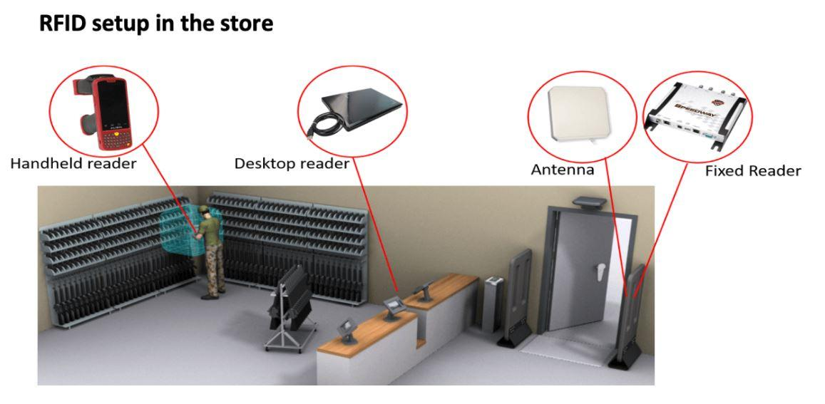

**Figure 5.1** RFID Setup in The Armory

A smart Weapon Management System is also required to ease the workload of the staff in the military, including the students, for a better learning process. This system would replace the management of surplus stores. This intelligent weapon management system will offer them with quick access and the ability to shape information. Store management may be utilised to automate the process of service fulfillment and will also manage the products that come into and leave the armoury. This process seems to require a good database management process as automation for the replacement of human workers by Data Science Technology. This application also will take care of all requests reducing the cost of spacing, documentation, and transportation while improving the efficiency and security of the service. It significantly improves service quality, optimizes the flow of items and shortens the time between users and staff at amory. It also will improve visibility and decision making providing efficient execution of tasks using this fast and reliable computerized method. The computerized method of RFID Technology also involves the element of Data Science and Machine Learning such as Figure 5.2.

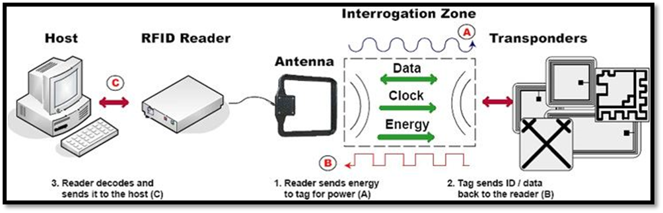

**Figure 5.2** RFID Setup in The Armory

During the processing of transfers and returns, a smart weapon management system will also have the capability to monitor and search for information regarding weapons certifications and other database lookups of a similar nature. A single "instance" of the database that makes up the smart weapon management system can be modified to simulate and maintain records for a wide range of other things. These can include records, evidence, the current status of the weapon, and its readiness for both training and operational purposes. The software supports both Windows and Linux operating systems and provides cross-platform functionality.

A smart weapon management system allows for a limitless number of item types, locations, users, and records to be stored in the system. The software as well as the RFID tag included in the tracking smart weapon management system is a Weapon Tracking Screen. Consequently, a smart weapon management system utilises software screens and/or USB-connected scanning devices to give comprehensive performance and tracking capabilities. This is accomplished with a low expenditure. RFID (Radio Frequency Identification) tracking is the most advanced method for tracking weapons currently available. This method involves embedding or attaching unique RFID tags to the weapons being tracked. The serial number of the weapon or object can be found in the database and is connected to the RFID tag.

Additionally, the personnel may also be RFID-identified through the utilisation of RFID name badges, which may be distributed to any authorised individual. Motion detectors are installed on both sides of a doorway or window so that they can determine the direction of travel (forward or backward) based on which detector is activated first. Additionally, the RFID technology is activated by the sensors, and the RFID antennae detect any individuals or goods that are entering or exiting the armoury (Li, et al, 2016). The User Experience (UX) of the smart weapon management system will be similar to Figure 1.3, and the User Interface (UI) of the system will be fundamentally tied to the UX.

The database of the smart weapon management system will be updated to include the person, the RFID data item, and the position of the RFID read zone. Additionally, the system will document the time and date of the transaction. It is possible to install flashing light stacks and a smart weapon management system as a part of RFID implementations. Portable RFID Scanners can be utilised after shift changes and whenever else it is suitable to quickly inventory firearms and other gear. It is also possible to employ portable scanners to inventory objects that have been sent to posts or other non-armory places. In addition, portable RFID scanners make it possible to locate lost or misplaced things. These scanners function in a manner analogous to that of a metal detector in that they direct users to a particular object.

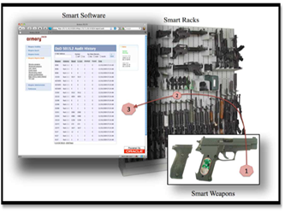

**Figure 5.3** RFID Setup in The Armory

This project's objective is to develop a weapon storage management system for the military by tracking weapons and all related equipment using software screens (web-based applications) and RFID (radio frequency identification) technologies. Such a system would be able to maintain an accurate inventory process, transaction details of weapons or other armoury items, and get transaction details for the takeover or handover (issuing) of the weapons, in addition to providing the necessary related information to the army. The high-level business objectives for the project are to:

a. Assist in the administration of the weaponry (easier recording, monitoring, and controlling).

b. Reduce the number of instances in which transaction records and actual quantities held in the armoury differ from one another.

c. Improve the planning for the new computing system that will be implemented in the future.

d. Make it possible for the timely arrangement of the maintenance schedule for the objects in the inventory.

e. Reduce the amount of time spent on each transaction carried out in the armoury.

It is believed that the proposed smart weapon management system for weapons management system will have user-friendly interactive web interfaces and reports with required details and charts for the users (army personnel) who are working in the armoury rather than for the other staff and students in the military. This is because the proposed smart weapon management system is intended for the weapons management system. Because of the stringent safety measures that are in place in the armoury, a member of the staff or a student (who is part of the army personnel) can't go there each time to take over or hand over the weapons. Therefore, a standalone solution is not sufficient to address the issue. If one were to investigate the connections between these parties, one might find that there is the potential for one-to-one as well as one-to-many connections between the members of the armed forces and the staff of the armoury. This might make the challenge of properly managing the weapons even more difficult. Thus, the project objectives are to:

a. Make use of the resources provided by ICT to automate the manual work procedures that are now being used for inventory processing.

b. Enhance the effectiveness of the day-to-day processing of inventory and reallocate the staff resources you save to deal with other, more pressing concerns about procurement.

c. Increase the vigilance with which the loss or surplus of inventory goods is controlled and monitored.

d. Reduce the amount of processing time as well as the amount of work required to carry out annual physical inventory checks.

e. Offer online inquiry and report facilities for the status and balance of inventory items, such as the distribution of software and the processing status of things that are to be disposed of.

f. It is important to provide online data that may be used by other connected systems, such as the software asset management system, the procurement of maintenance services, and so on.

**5.2 RELATED WORKS (TRADITIONAL TO MODERNIZATION)**

To more effectively carry out ongoing military operations, a smart weapon management system may be utilised as an extended platform. Currently, the military Ministry of Defence is still using the conventional approach. This means that whenever army personnel wish to request to use their weapon for the Road Block Inspection operation, they will be required to queue and wait inordinately long for the appointment date to withdraw the weapon. Taking the current scenarios faced by every government regarding the COVID-19 outbreak as the related works for this new system, this is one of the related works for this new system. However, the circumstances became a great deal more challenging after the COVID-19 standard of operation was implemented (SOP). In addition, it was stated that as part of "Operation Penawar," military personnel had been mobilised with the use of weaponry to enforce the Recovery Movement Control Order (RMCO), the Targeted Enhanced Movement Control Order (TEMCO), and the Conditional Movement Control Order (CMCO) in all affected areas. In this context, "border control cooperation" refers to the enhancement of such collaboration, which falls within the purview of the Eastern Sabah Security Command (ESSCOM).

The entirety of the operation will need that the military troops withdraw their weaponry daily, which may also have an impact on the management of the armoury as of late. To prevent the weapon from being mishandled or lost in any way, every piece of information about the inventory transaction of the weapon must be correctly recorded and checked for accuracy. The conventional method of managing weapons consists solely of employing a numbering system similar to that which is displayed on the weapon rack (see Figure 1.4). Other related works as the main indicator issues in terms of the managing and issuing of weapon problems are as follows:

a. Before being involved in any actions involving the use of a weapon in the field, members of the armed forces will be asked to fill out a form each time they use their weapon. This is seen as a hardship for them, and there is even a cost associated with the usage of an excessive amount of paper to satisfy the requirements of several different army people at the same time.

b. The members of the Armory Staff have to physically count each weapon and item in the store, which raises the possibility that mistakes will be made. It will eventually turn out to be the true offender regarding the entire weapon store management system.

c. In addition, the Armory Staff is responsible for conducting the inventory checking twice each day with two individuals on task, and it will take them an average of 1.5 hours to count each inventory item as part of their regular job routine.

d. To store all of the weapon racks and filling systems, the military will need to construct more space, which will be expensive for the military in the future administration.

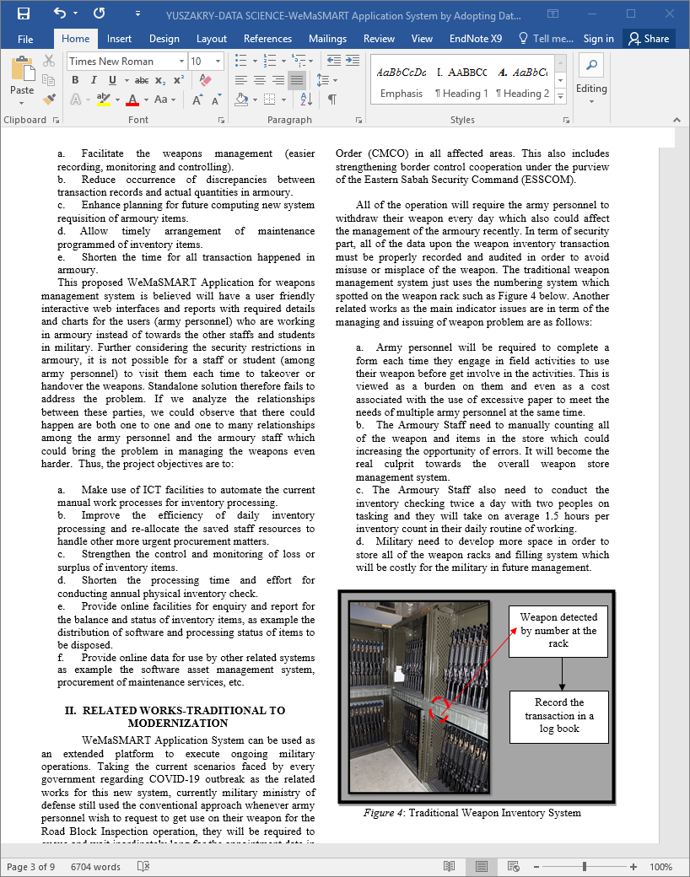

**Figure 5.4** Traditional Weapon Inventory System

**5.3 NEW OPPORTUNITY FOR DATA SCIENCE**

The smart weapon management system makes use of data science about the logistic management of the weapon to optimise routes to ensure a speedier working environment in the military Ministry of Defence and to boost its operational efficiency (C.Stedman, 2022).

Recently, Data Science has emerged as a hot topic of discussion in the field of computer science among both professionals and associations. Some organisations are beginning to place a higher priority on the value of information. As a result of the introduction of massive amounts of data, also known as Big Data, the need for capacity increased by a factor of several. Building a foundation to store vital information that can be accessed and managed in the future to derive hierarchical experiences was a big focus of the future project of a smart weapon management system. This foundation was the significant heart of the project. However, because the capacity issue has been resolved, the focus that is currently being given is on how to manage the information and make use of the information to resolve the issue, come up with solutions, and fulfill the requirements of the military organisation. Every single one of these procedures has the potential to have an impact in terms of the decisions that are made by commanders as well as the operational environment in the military Ministry of Defence. The engagement of the three different domains, including the physical domain, the information domain, and the cognitive domain, is illustrated in Figure 5.5.

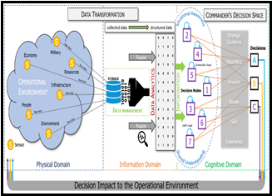

**Figure 5.5** Data Transformation Toward Commanders Decision Making

Data science plays an important role in every aspect of the work and systems carried out by the military and the Ministry of Defense. It is essential for progress to be made on this project as well as pushing arrangements across several different endeavours at the moment. For example, data science provides information about weapons and the troops who use them, which enables the military to make more intelligent efforts and perform more designated organising to construct better agreements for weaponry. Another model is that it facilitates the monitoring of monetary risks, the detection of fraudulent transactions, and the prevention of digital assaults and other types of security risks in data frameworks. Data science is also crucial in this location outside the typical economic operations that take place here, such as in the field of medical care. The diagnosis of diseases, the examination of images, the preparation of treatment plans, and the conduct of clinical research are all examples of its applications.

The discipline of data science focuses on developing effective workflows to investigate, imagine, and display large amounts of data. The technique of data science could provide the military Ministry of Defence Data Analysis with assistance in the utilisation of the equipment to observe inconspicuous examples, extract information, and convert data into noteworthy pieces of knowledge that can be significant. Data science is an essential component in the development of the smart weapon management system since it enables predictive displaying, design acknowledgment, irregularity identification, characterisation, categorization, and opinion research.

Along these lines, it is considered that the interaction between data science and smart weapon management system development would help in locating the secret examples of organised and unstructured crude information to satisfy the prerequisite for the improvement of the smart weapon management system. To create an intelligent weapon management system that combines RFID technology with other aspects of disruptive technologies, many processes in data science need to be completed. These procedures must be completed before the system can be developed. As a result of the fact that a smart weapon management system that makes use of Big Data technology is a collection of information that is either high in volume, high in volatility, or high in diversity, it is necessary to employ novel processing techniques to facilitate decision-making, the discovery of new phenomena, and the optimization of processes. Big Data is too enormous for standard data-processing systems and software tools to capture, store, manage, and analyse; as a result, it requires a combination of technologies to manage (capture, aggregate, process) its volume, velocity, and diversity (Gunasekaran et.al, 2018).

The five steps of the data science process that were used in this development project are based on the OSEMN Framework in Figure 1.6. This development future project is based on the OSEMN Framework in Figure 5.6. This development future project is a very complex process consisting of various steps taking massive amounts of effort to achieve continuous excellent results.

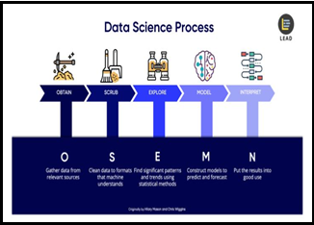

**Figure 5.6** OSEMN Framework of Data Science Process

**5.3.1 Obtaining the Data**

The very first stage in a project involving data science is an easy one to do. Get the information you require from the various available data sources. RFID presents a plethora of advantages for establishments affiliated with the military or the Ministry of Defence. Major cost savings and considerable improvements in the overall operational efficiency of the military will be the direct result of significant increases in the capabilities to capture more data, the integrity of that data, and the visibility of the supply chain.

One method of obtaining data is to obtain it via scraping it from websites of the military Ministry of Defence Human Resources Information System (HRMIS) or the military Logistic System using web scraping tools. These files consist solely of plain text. In the past, it was necessary to use a unique Parser format because a conventional programming language such as Python did not grasp it natively. If this smart weapon management system is going to deal with considerably larger data sets, then it will need to learn how to access distributed storage using software such as Apache Hadoop, or Spark.

**5.3.2 Scrubbing the Data**

Scrubbing the data is the next step in the data science process, which comes immediately after collecting the data and before analysing it. During this procedure, we are going to "clean" the data as well as filter it. Because RFID tags have a significantly higher capacity to retain data, this technology is an ideal choice for the identification of every object involved in the process of weapon management. RFID tags can receive programming updates in real time and can provide data scanning in real-time as well.

During this step of the process, the data that have been acquired need to be converted from one format to another and then consolidated into a single format that is standardised across all of the data. For instance, if the data is kept in several CSV files, it will combine all of these CSV files' worth of data into a single repository to be able to process and analyse the information.

It may also be necessary to filter the lines in certain circumstances, such as when users are working with locked files. Scrubbing data also entails the process of a process of value extraction and replacement, in addition to the previously mentioned steps. If it discovers that there are RFID data sets that are missing or have no value, now is the moment to change them according to the situation.

Last but not least, it will require splitting, merging, and extracting columns. For the location of origin, for instance, we might have "Weapon Name" and "Weapon Brand" in the same sentence. It is possible that to satisfy the needs of the military Ministry of Defence, we will need to either combine or separate this data.

**5.3.3 Exploring the Data**

After the data has been prepared for usage and just before moving on to artificial intelligence and machine learning, it will be necessary to analyse the data. On a typical day at work in the military, the commanding officer will provide us with a collection of data, and it will be up to us to decipher what it all means. As a result, it will be up to us to guide them through the process of transforming the military topic into a question about data science. In addition to that, for us to accomplish that, we will have to investigate the data.

To begin, we will have to perform an analysis of the data as well as its features. Different kinds of data will call for various approaches to analysis. After that, the following step is the computation of descriptive statistics to examine significant variables. Using correlation is a common method for determining the significance of variables. Examining, for instance, the dangers faced by the armoury staff when obtaining a high volume of inventory items in proportion to their type, height, and weight.

The ability of RFID to provide a more granular level of visibility is the primary advantage of using this technology. If we have better vision, then we will be able to notice more distinct things and more states. Without RFID, results in a larger variance in judgments, which demonstrates the bull-whip effect. If we are successful in utilising RFID to collect a comprehensive data set in addition to more specific information, we will be in a position to react with greater precision and lessen the amount of jitter that takes place throughout the process of developing this project. If we can determine which details are most important using statistical process control, we will have this knowledge.

The term "Feature" refers to the data features that assist us in identifying the qualities that constitute the data. This phrase is used in the context of machine learning and modelling. A standard army personnel dataset would have columns labelled "Name," "Age," and "Gender," for instance. In the end, we will make use of data visualisation to assist us in recognising key patterns and trends within our data. We may get a clearer image of the situation by using straightforward charts, such as line charts or bar charts, which will assist us in comprehending the significance of the data.

**5.3.4 Modelling the Data**

When it comes to modelling data, one of the first things we need to do is cut down on the number of dimensions contained in our data set. Our ability to anticipate the future is not dependent on every one of our features or values. What needs to be done is to zero in on the factors that are pertinent and make a contribution to the forecast of the results.

In terms of modelling, there are a few activities that we can carry out. We may also train models to do classification using logistic regressions, which will allow us to differentiate between an "Inbox" online application and a "Spam" online application that we have received. Utilizing linear regressions also allows us to make value predictions. Additionally, modelling can be used to group data to better understand the reasoning behind the clusters. For instance, to better understand the behavior of our users on our online application, we group our smart weapon management system users, who are members of the military. This needs us to identify groupings of data points through the use of clustering techniques such as k-means or hierarchical clustering, which is accomplished through the process of machine learning. In a nutshell, we make use of regression and forecasts to forecast future values, classification for the purpose of identifying, and clustering for the purpose of grouping values.

**5.3.5 Interpreting the Data**

The interpretation of the models and data is the very last step of a data science project for a smart weapon management system, and it is also the most important step. The capacity of a model to generalise is directly correlated to the accuracy of its predictions. How can we explain that the success of a model is dependent on its capacity to generalise information about events that have not yet occurred? The act of presenting our findings to someone who is not technically trained is what is meant by "interpreting the data." We deliver the results in order to answer the queries regarding the military base that we posed when we first began the project. These results also include the actionable insights that we discovered while going through the data science process.

We explain how predictive analytics and, later on, prescriptive analytics can be brought about with the help of data science, and one of the most important outcomes is actionable insight. In this we learn how to achieve a positive result more than once as well as how to avoid an undesirable result. On top of that, we will need to portray our findings in the appropriate manner, making sure to keep it driven by the queries we have about the military base. If we do not deliver our findings in a way that is valuable to the military organisation, then our efforts to improve the efficiency of our working environment will be for naught.

In this process, only having technical abilities is not enough on its own. One of the most important skills we need is the ability to tell a tale that is understandable and has takeaways. If the activities that our user's requirements require are not triggered as a result of our presentation, then it indicates that our communication was not effective. Keep in mind that you will be presenting to users (military people) who have no prior experience with technology; therefore, the manner in which we transmit the message is quite important. In addition to the software that is required for data visualisation, such as Matplotlib, ggplot, Seaborn, Tableau, and so on, we require "soft skills" such as presentation and communication abilities. These abilities, along with a natural talent for reporting and writing, will undoubtedly be of assistance to us during this data science process stage of the project lifecycle.

**5.4 RESULT AND DISCUSSION**

This smart weapon management system relied significantly on various innovative technologies including Internet of Military Things (IoMT), Machine Learning, Artificial Intelligence, and Big Data. It did this by utilising RFID Technology and embracing the Data Science technology.

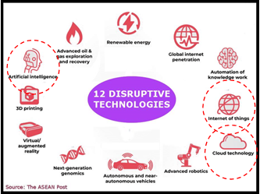

**Figure 5.7** Disruptive Technologies

The term "disruptive technology" refers to a development that significantly alters the way in which established business sectors, companies, individuals, and organisations function. As a result of the plainly dominant traits it possesses, it takes the place of grounded frameworks, products, and even habits. The RFID technologies that have been employed as the primary technology for this smart weapon management system already contained a component of a disruptive technology, which was one of the elements of this system's disruptive technology (D.Rotalli, 2019). The Internet of Things, Machine Learning, and Cloud Computing are three more disruptive technologies that are also involved in order to support the development of this project and are related to data science.

**5.4.1 Internet of Military Thing (IoMT)**

The Internet of Things has significant implications in the military, including the connection of ships, planes, tanks, drones, soldiers, and operating bases into an unified network. This improves situational awareness, risk assessment, and response time. The Internet of Things (IoT) is a developing field that envisions an interconnected world full of physical and virtual things, technologies, processes, and services that are able to provide a different perspective on how to link them over the internet. This is the vision of an interconnected world. As a component of the Future Internet, the Internet of Things has been conceptualised as a paradigm that primarily aims to integrate and enable a variety of different communication methods and technological solutions.

The Internet of Military Things refers to a wide range of different intelligent physical sensing devices that are also capable of learning, and communicating with one another. and actuation by means of virtual or cyber interfaces that are built into various military systems. These devices are connected to one another via the internet. Gadgets such as sensors, vehicles, robots, unmanned aerial vehicles (UAVs), human-wearable devices, biometrics, ammunition, armour, weaponry, and other forms of intelligent technology are included in this category. IoMT devices can typically be placed into one of these four categories, according to their primary function:

a. Data-carrying device: A device that is physically linked to an object and provides that object with an indirect connection to a broader communication network.

b. Data-capturing device: An electronic reader and writer that is also capable of interacting with real-world objects.

c. Sensing and actuating device: A device that can detect or measure information linked to the environment around it and turn that information into a digital electronic signal or a physical operation is called an environmental sensor.

d. General device: A hardware component that is embedded with processing and communication capabilities and has the ability to share information with a wider network.

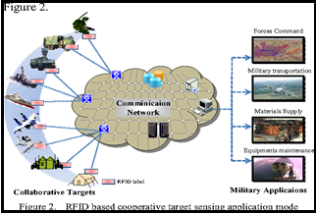

**Figure 5.8** IoMT in smart weapon management system

This project will involve the entirety of the military's operation, beginning with the process of weapon inventory and continuing all the way through to the point where the weapon is used for the purpose of any type of military operation, our current plan calls for it to be developed in terms of all categories. This application will entail the Command of the Forces, military transportation, the provision of materials, and the upkeep of equipment (inventory management system).

A powerful communication network that is connected via a protected military network and a number of devices will be made possible by the IoMT. For instance, if RFID technology is utilised in the

, each and every weapon will undergo an automatic scan and be registered in the corresponding database. This data will be used via the network in order to communicate within the network, and it will provide real-time information regarding the movements of weapons, the individuals engaged, and the total readiness amount of assets that are ready to be used right away.

The digital domain is responsible for managing the relationship that exists between the various identifiable elements that make up the system. It necessitates the utilisation of global standards like the Globally Unique Identifier (GUID) and the Universally Unique Identifier (UUID). The Internet of Things (IoT) will often identify objects through the use of Radio Frequency Identification (RFID). The RFID tags are able to detect the items and read the information contained within them through a wireless operation. An electronic label, a tag reader, and a controlling computer are the three essential components of an RFID-based system. The tag could be an electronic card with a radio frequency or an IC card that does not require physical touch. Control and data storage are both provided by an electrical circuit on a chip, and this circuit is connected with an antenna.

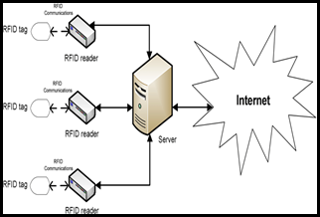

**Figure 5.9** Connecting RFID Technology to IoMT

They are going to communicate through the internet all of the data that was computed during the data science process. Both the user, who is a member of the army, and a higher-level authority are able to use the data in order to arrive at their own choice regarding what is best for them.

**5.4.2 Machine Learning-Deep Learning Process**

The field of advanced analytics known as machine learning involves computer programmes that teach themselves about data sets and then search for patterns, outliers, or insights hidden within those sets. It employs a number of different learning strategies, including supervised, unsupervised, semi-supervised, and reinforcement learning.

Deep learning is a subfield of machine learning that is a more advanced offshoot that focuses mostly on the use of artificial neural networks to analyse big data sets. Another fundamental component of data science technology is predictive models. Data scientists develop them by using various learning and analysis techniques, including as machine learning, data mining, and statistical analysis, to collections of data in order to make predictions about possible outcomes or behaviours.

By utilising a deep convolutional neural network, we were able to construct a system for the recognition of complicated activities based on RFID data. Our system conducts classification of activities or procedures using multiple classes phases, and it works directly with data collected from RFID tags. These existing systems are organised in a hierarchical manner. It performed significantly better than our most current system, which relied on prefabricated RFID components for activity recognition. Machine learning is a process that can examine data and then utilise that information to generate conclusions based on the recognition of patterns. This method has been described as the method by which technology can learn. Disruptive machine learning is a technology that educates computers to discover important patterns in data and to make decisions with a high degree of precision.

As is done in image analysis, we viewed and examined the neuron activations in each convolutional layer. This is similar to what is done in image processing. We have found that our system is able to identify highly specific RFID properties for the purpose of recognising activities and detecting process phases. We were able to validate our hypothesis by substituting 0s for the input points that our network deemed to be significant, which resulted in a significant drop in overall performance. On the basis of this investigation, we also found possible next advancements in deep learning using RFID data.

RFID data were acquired by numerous antennae from various tags on the same or separate things, which resulted in two additional dimensions. These tags might be on the same object or on other objects. We decided to employ a Convolutional Neural Network (CNN), in addition to the receiving antenna and the item/tag ID, since we needed to process the data from all of the tags simultaneously in order to capture any potential concurrent usage of the object. By encoding information as a high-dimensional matrix, CNN is able to handle input with a high dimension more effectively. In addition to this, CNN is efficient at learning features and rather than raw data, it takes extracted features as its input (Srivastava et. Al, 2014). Given that it is difficult to manually optimise selected features, utilising a poor selection will result in poor performance because it will lead to a poor selection. CNN's trainable filters enable it to produce features that are beneficial to users.

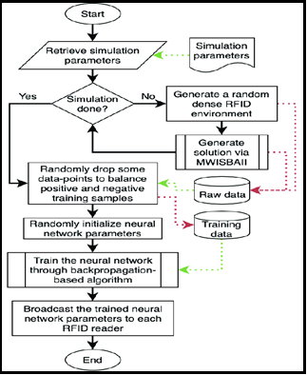

**Figure 5.10** Flowchart of Machine Learning (deep learning)

**5.4.3 Cloud Computing-New Proposed Technology in Military**

Cloud computing refers to the distribution of services as well as the method in which they are used. More specifically, it describes the usage of a network in an on-demand, scalable manner to achieve the service that is desired. This service could involve information technology and software, the internet, or some other type of service. The term "cloud" refers to this shared pool of resources. The term "cloud" refers to a collection of virtual computing resources that are capable of performing their own upkeep and management. These resources are typically reserved for use by a cluster of servers on a massive scale and include the computation of servers, servers for storage, internet and other resources, and so on. The concept of cloud computing involves pooling all of a company's available computing resources into a single pool, which is then controlled entirely by software and operates independently of any human intervention. This frees the application provider from the burden of worrying about insignificant particulars, allowing them to concentrate more intently on their own operations. This, in turn, fosters creativity and cuts costs.

As a result of the necessity to conduct operations all throughout the country, the military is now taking a new step toward establishing its very own cloud computing system. This is because the management of vast amounts of server space and big data will be required. Therefore, by constructing this brand-new intelligent system for the military in, it is believed that they would fully utilise the aims for having cloud computing for the future development of the military ministry of defence.

A computing platform that is cloud-based and is used for RFID network architecture. The operator can compute platform abstraction computation and storage resources by using cloud, integration middleware services, dynamic allocation to require the use of the user or the application, development of business applications that need according to the standard application programme interface call resources required for the on the cost, with the total amount of use of resources being proportional to the throughput.

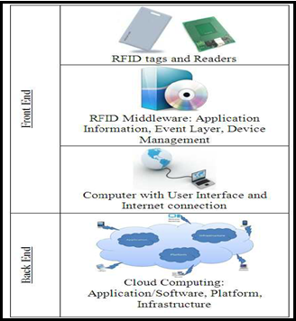

**Figure 5.11** RFID, Data Science and Cloud Computing Proposed Architecture

**5.5 CONCLUSION**

Research on the application of smart system management has assisted in the improvement of the effectiveness and performance of weapon management systems in a number of developing countries, such as the United States and Australia. This research has also contributed to the improvement of regulations concerning security and safety. When a code is used as the query value to retrieve relevant information over the network, relevant information is obtained from an RFID tag, which holds a one-of-a-kind code to mark the reality of items. The information pertaining to the business process is saved in a data container. When integrated with Internet technology, data science, and machine learning, RFID technology has the potential to realise information exchange on a worldwide scale. RFID technology can also recognise numerous tags at once and has a quick identification speed. Motivated to design this system for the military ministry of defence by using response speed, integrity, and performance efficiency as our barometers, we created this system for their advantage (Chen et.al, 2014). Additionally, we believe that military personnel will profit from the implementation of a smart weapon management system since it will promote flexibility to shifting work situations. When it comes to the technology of cloud computing, the military and its ministry of defence need to be more precise and properly focus their attention from this point forward in order to secure not only the successful growth of this project but also the development of any future projects. In the future, we could be able to develop this project so that it includes new improvements on new disruptive technologies, which will serve as sustaining technologies.

**ACKNOWLEDGEMENT**

This work was funded by the Ministry of Higher Education of Malaysia under Fundamental Research Grant (**FRGS/1/2021/ICT03/UTM/02/2).** We also thank to the Malaysian Armed Forces (MAF) for scholarship funding of this Master's Degree study.

The completion of this study could not have been possible without the expertise of officers and other rank from Cyber and Electromagnetic Division. We also would like to express many thanks to Azlizam and Zaki for providing us with the guides for our project’s framework.

**REFERENCES**

Chen, Y., Wang, Y., Nevo, S., Jin, J., Wang, L. and Chow, W.S. (2014).

IT capability and organizational performance: the roles of business process agility and environmental factors, European Journalof Information Systems, Vol. 23 No. 3, pp. 326-342.

C.Stedman.. (2018-2023).

What is data science? The ultimate guide. https://www.techtarget.com/searchenterpriseai/definition/data-science.

D.Rotalli (2019)

5 Disruptive Technology Examples in Intelligent Automation. *https://blog.bisok.com/general-technology/5-disruptive-technology-examples-for-your-industry#rpa*. August 19, 2019.

Li, Xinyu, Dongyang Yao, Xuechao Pan, Jonathan Johannaman, JaeWon Yang, Rachel Webman, Aleksandra Sarcevic, Ivan Marsic, and Randall S. Burd (2016).

Activity Recognition for Medical Teamwork Based on Passive RFID." IEEE International Conference on RFID. IEEE, 2016.

Gunasekaran, A., Yusuf, Y.Y., Adeleye, E.O. and Papadopoulos, T. (2018).

Agile manufacturing practices: the role of big data and business analytics with multiple case studies”,International Journal of Production Research, Vol. 56 Nos 1-2, pp. 385-397.

Srivastava, Nitish, Geoffrey E. Hinton, Alex Krizhevsky, Ilya Sutskever, and Ruslan Salakhutdinov (2014).

Dropout: a simple way to prevent neural networks from overfitting." Journal of Machine Learning Research 15, no. 1 (2014): 1929-1958.