**CHAPTER**

**6**

# HIGH-PERFORMANCE COMPUTING ADOPTION APPROACH FOR SMART WEAPON MANAGEMENT SYSTEM

*Musa Karsimin and Anazida Zainal*

* 1. **INTRODUCTION**

An innovative method of work that is suitable for application in a military setting is referred to as a smart weapon management system. Making use of the Internet of Military Things (IoMT) is the objective of this strategy. Doing so will enable military leaders to plan, which will include the capability to pre-plan activities online. The procedure stipulates that military personnel who have been granted authorization will finish the majority of their duties prior to reporting to the armoury. A commanding officer who is given an order to deploy may utilise the system to verify the state of his weapon and manage his crew in accordance with the availability of the information.

The secondary objective of this paper is to present a weapon storage management system for the military that is capable of tracking weapons and all associated equipment using software screens (web-based applications) and RFID (radio frequency identification) technologies. This type of system would be able to maintain accurate inventory processes, transaction details of weapons or other armoury items, and get transaction details for the takeover or handover (issuing) of the weapons, in addition to providing the necessary information. The planned smart weapon management system for weapons management will not be targeted toward other military officials; rather, it would offer reports with the essential facts and charts for the users (army members who are working in the armoury).

Utilizing software screens, bar codes, and technology known as Radio Frequency Identification (RFID), this tracking system was developed with the sole purpose of keeping track of firearms. The programme will be developed and adapted to meet the specific requirements of the armed forces in response to each individual circumstance that arises. The programme may be quickly set to use the language (data fields) of each individual service member's choosing, it can automate workflow, and it can provide reports that are in line with either the preferred or the actual operating procedures.

A smart weapon management system not only keeps tabs on the weapons and equipment in its possession, but it also has software components that keep tabs on the cleaning and inspection of such weapons, as well as their maintenance and testing. Armory administrators utilize these solutions to enhance equipment flow, reduce inventory discrepancies, and secure the chain of custody. This ensures that only authorised individuals have access to the appropriate equipment. Management solutions for armouries are able to be adapted to meet the specific needs of any individual armoury.

Components of typical hardware include a fixed unit, a mobile unit with a touchscreen tablet, and an equipment tag used to scan and record all inventory into the database. Each of these three types of units is known as a mobile unit. In addition to simplifying the checkout process, sophisticated solutions can help prevent the improper usage of equipment. Some forms of military instruction and activities might incorporate aspects of managing armoury inventories, which are comparable to software for managing physical evidence. In order for military officials to satisfy all of their safety requirements, specialised armoury management solutions are developed and configured.

* 1. **RELATED WORKS**

At the moment, members of the armed forces have to present themselves in groups at the armoury in order to retrieve a weapon for use in either training or deployment to a combat zone. Because of this, the area will become more crowded, which will have a negative impact on the process of developing new operational processes and standards of practise during this pandemic caused by Covid-19. In addition, because there is a shortage of employees at the already overcrowded armoury, they have to wait for a considerable amount of time before being served.

It is possible that when they get their weapon and bring it to the shooting range for practise, they will find a firearm that has not been calibrated. This will cause their training session to be of poor quality and will waste their time. This occurred as a consequence of the withdrawal being carried out in bulk, and there is a significant risk of the addition of weapons that has not been calibrated. In addition, transporting a weapon that is not in working order runs the risk of a service member's death and has the potential to reflect poorly on the unit.

The organization's stores, inventory, and purchases are all handled by the Logistic Support Department. The crew is responsible for handling the weapon store in every unit across the country, which includes the manual processing and upkeep of all inventory data. Paper folders were used to organise all of the weaponry and inventory items so that they could be easily retrieved, and some of the records were also kept in spreadsheets or other word document formats. Some branches of the armed forces have retained their long-standing management practices for their weaponry.

The Information and Communications Technology (ICT) department is currently looking for a computerised system for managing weapons in a more effective manner via a smart application to manage the storing of inventory records and to facilitate inventory management and control activities such as the withdrawal of weapons by army personnel in their routine daily working environment. This search is being conducted by the ICT department. This essential SMART Application will also make it simpler for staff members to perform periodic physical inventory audits and inventory transfers, write-offs of missing stocked items, and the liquidation of excess store goods.

In order to overcome and resolve this issue, a more effective weapon management system is required because of the scenarios that have been described above. In addition, as the field of information technology and communication continues to progress, numerous nations are implementing automated management systems for their military hardware and supplies. In addition to being able to automatically gather and analyse data, it can also establish a national network and finally share and transfer data in real time.

**6.2.1 High Performance Computing**

When it comes to computers, we can predict that significant progress will continue to be made in the next years. Moore's Law, which states that the capacity and speed of computers double every 18 to 24 months, might or might not continue to remain true as it has for a number of decades, despite the fact that rapid advancement seems guaranteed to continue. There is a possibility that Moore's Law will continue to remain true as it has for a number of decades. By the year 2000, the number of transistors that could be placed onto a single chip had climbed to around 10 million, and by the year 2015, it had surpassed 1.45 billion. The ability to fit several thousand transistors onto a single chip became conceivable around the year 1970. Even if the rate of advancement comes to a complete halt, it won't be because it won't stop happening at all. In addition, various strategies will be developed in order to make the most of all of these already available computer capabilities. These strategies have a great deal of unrealized promise in a number of different areas of study.

High-performance computing (HPC) can be defined as computer systems that are capable of tackling challenging computational tasks in a number of scientific, technical, and medical fields. and business domains by combining processing power and storage capacity. HPC is a crucial, game-changing technology with significant ramifications for national security, scientific leadership, and economic competitiveness. Due to the fact that HPC is at the cutting edge of scientific research and business innovation, it is at the forefront of rivalry among governments and enterprises.

The number of floating point operations that can be performed in a second is the performance metric used for HPCs (FLOPS). There are high-performance computing systems that are currently capable of performing quadrillions of FLOPS. The first high-performance computing systems had only a handful of processors, but as time went on, systems with thousands of processors were developed. By the end of the twentieth century, supercomputers with huge parallelism with tens of thousands of commercially available CPUs became the industry standard. Tianhe-2 HPC is presently the fastest supercomputer in the world, with a performance of 33.86 petaFLOPS (PFLOPS), which is equivalent to 33.86 quadrillion floating point operations per second.

High-performance computing is the use of large parallel processing techniques and the utilization of supercomputers for resolving challenging computational problemsthrough the use of computer modelling, simulation, and data analysis. High-performance computing is also known as HPC. In order to solve difficult problems in a quick and effective manner, high-performance computing incorporates a number of distinct technologies into a single system. These technologies consist of things like computer architecture, programming, and electronics, as well as application software and software for developing algorithms. An HPC system is, in its most basic form, a network of central processing units (CPUs; also known as microprocessors), each of which comprises a number of computing cores in addition to its own local memory and is designed to run a variety of software applications. An HPC system is a desktop computer or workstation that consists of many processing chips.

The computer programmes that computer programmers build for supercomputers are broken down into a large number of smaller, more autonomous processing jobs that are referred to as "threads." These threads are able to execute concurrently on the cores of the computer. Because modern supercomputers can have more than 100,000 "cores," or processing units, each core needs to be carefully crafted to ensure that data is transferred as quickly and effectively as possible. (For instance, the United States' Titan supercomputer, which is ranked the second fastest in the world, has slightly fewer than 300,000 processing cores and is capable of running more than 6,000,000 threads simultaneously.

Jobs that are computationally, numerically, or data-intensive, as well as tasks that require a large number of complicated computations to be completed quickly on large data sets, are ideal candidates for use on HPCs. HPCs are especially well-suited to jobs that are data-intensive. In all fields of study that need a significant amount of computation, such as physics, earth sciences, national security, biology, engineering, climate modelling, aerospace, and energy, high-performance computers are extremely important tools.

While HPC adoption and use are important for a variety of reasons, at least five stand out conceptually:

1. Each incremental improvement in HPC signifies a change of an order of magnitude that enables either new applications or more efficient use of existing ones;
2. With the advent of computational simulation (often known as "theoretical" research), HPC is redefining the scientific method itself;
3. HPC will be required as an innovation platform in order to manage the enormous expansion of data;
4. At least for high-performance systems, HPC is one approach to addressing the decline of Moore's Law; and
5. A wider variety of commercial and institutional customers, including small to medium-sized businesses, will be able to access high-performance computing systems as a result of their prices continuing to fall (while at the same time their capabilities continue to improve).

In the not-too-distant future, HPC will be an improved sub-discipline of computing that will contribute to the development of the Weapon Management System for the armed forces. This prediction is based on the concepts that were mentioned above. The employment of high-performance computing in commercial and industrial settings, particularly in defence departments with a primary focus on national security, results in a number of benefits and added value. In particular, high-performance computing enables advanced modelling, simulation, and data analytics, all of which can help manufacturers address challenges and make decisions, optimise processes and design, improve quality, predict performance and failure, and speed up or even eliminate prototyping and testing.

In particular, HPC makes it possible to uncover ground-breaking discoveries, which in turn drives innovation. In particular, HPC can assist in the design of new products, the improvement of existing products, and the bringing of items to market much more quickly and efficiently. In addition, as was mentioned earlier, the ability to collect, analyse, and utilise data is becoming increasingly important in the development of future products, business models, industrial processes, and businesses. This has made the use of supercomputers an absolute necessity in industries that evaluate vast amounts of data.

When it comes to the proposed system that was discussed in the introduction part of this research, HPC has the potential to have a big impact by atomizing the system. If the entire armoury or even just the storage system in the military logistics chain adopts and integrates the suggested system as a whole, the effect will be seen. As a consequence of this, the benefits of high-performance computing can be used for the management of resources within the military's Logistics Department. In addition, the security system can be improved by the implementation of a centralised monitoring and reporting system. This system will assist in the feeding of information to higher-level decision-makers in the Armed Forces, which will help the system function more effectively.

The Armed Forces will implement more dynamic mechanisms for the operations of logistics and will stimulate the development of technologies that are capable of enhancing the military's fighting strength. This integration will combine mission-based characteristics of the organisation of the logistics team, as well as command and control that is more transparent and straightforward. An integrated database management system that operates in real-time will also be of assistance with this integration. As a direct consequence of this integration, inventory management will be carried out in a manner that is both more efficient and effective, and the costs of both operation and maintenance will be decreased. As a direct consequence of this, the operational mechanism of military logistics has evolved to become more dynamic, predictive, and agile.

As a consequence of this, incorporating HPC into this planning will further enhance development, in particular with the use of artificial intelligence in forecasting or predicting logistical requirements via centralised data centres that are linked and synchronised at all levels, while keeping security as a basic requirement. This will be accomplished by utilising artificial intelligence in forecasting or predicting logistical requirements via centralised data centres.

* 1. **PROPOSED SYSTEM**

The smart application system that is being developed will be an all-encompassing web-based solution for managing and controlling weaponry. This system is able to handle, monitor, and record a variety of different types of transactions that include armouries and army forces. In addition to this, it details their relationship in order to preserve their genuineness. The following is an in-depth summary of the scope of the project: This system is able to handle, monitor, and record a variety of different types of transactions that include armouries and army forces. In addition to this, it details their relationship in order to preserve their genuineness. The following is a detailed overview of the scope:

1. Ensure that all things pertaining to the military's arsenal are safely stored.
2. Keeping track of the specifics of one-to-one and one-to-many relationship dynamics between army soldiers and the armoury. In addition, information regarding the person who is granted permission to conduct transactions is going to be saved as well.
3. Verify that the details that have been provided by Military Personnel are correct.
4. Provide an accurate recording list of weapons to make the managing process easier.
5. Maintain all the details of the allocation/reallocation of weapons from the Armoury and details regarding the handover and takeover procedures between army personnel and the armory.
6. Alert administrators if someone unauthorized tries to access or detect non-normal transactions. For example, the unusual amount of handover and takeover of weapons and sending the feedback of the transactions to the higher authority.
7. Facilitate the following reports:
8. Daily handover & takeover of the weapon between army personnel and armory.
9. Daily allocation of weapons in the armory.
10. Daily stock report of weapons.
11. Transactions details of the weapon stocks.
12. Details of moveable/non-moving weapons.
13. Details of weapons conditions. For example, the operational and non-operational status of the weapons.
14. Details of inquiries from army personnel towards the armory.
15. Disposal of inventory items.
16. Trade-in of inventory items.
17. Write off/Replacement of lost inventory items.
18. Annual Physical Inventory Check.
19. Reports for inventory transactions and status of inventory items.
20. Interfaces with other related IT systems including Software Asset Management System for software licenses and e-Procurement System for maintenance services, purchase orders, and invoices

The relation between the subsystems within the application is shown in Figure1.1 below:

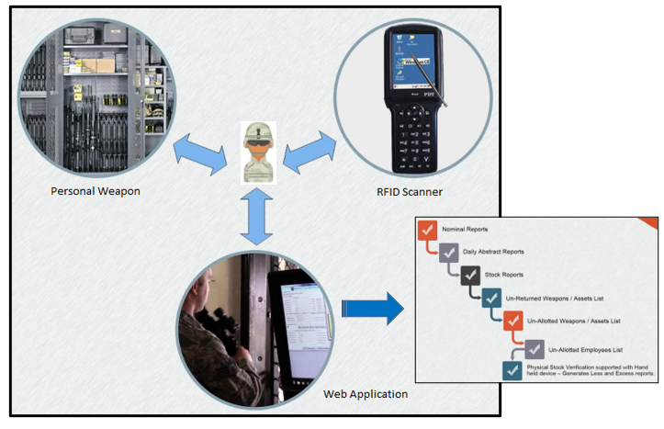

**Figure 1.1** Relationship Diagram

A sample of the setup of the system in the armory is shown in Figure 1.2 below:

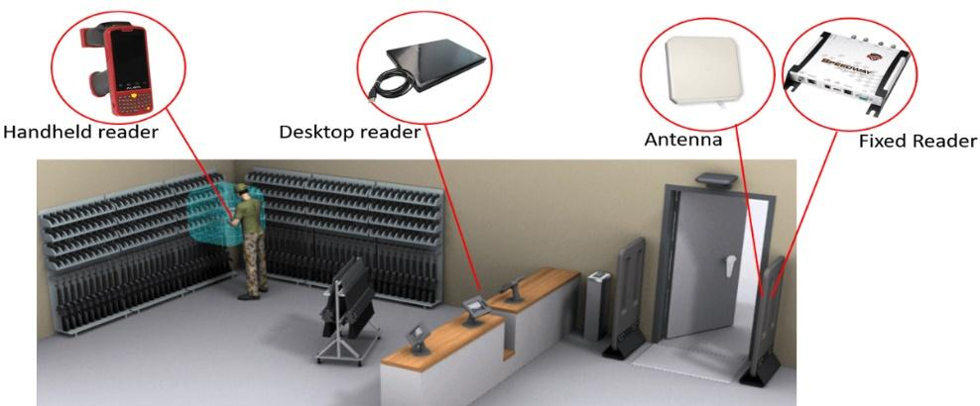

**Figure 1.2** Sample Setup in the Armoury

The efficiency of a weapon management system can be improved by implementing a smart weapon management system. Through the utilisation of web applications and RFID, man and machine are connected to one another and are kept apprised of all relevant information at all times. Logging in and registering oneself online will now be an option for military members seeking to withdraw a weapon, as opposed to the more conventional way. In response to the request that they made, the system will send them a notification with the date and time. You will receive a notification from the system regarding the day and time that you specified. As is the customary practise at this time, the military personnel will enter the armoury at the allotted time and retrieve the weapons off the rack without receiving any assistance from the armoury employees. In addition to this, the sophisticated management system for weapons is able to keep a record of weapon certifications and search for them. A single database for a smart weapon management system can be modified to represent and keep track of a wide variety of other items. These objects can include records, evidence, and the current status of weapons.

Both the armoury staff and the military troops can benefit from the user-friendliness of this system's application and administrative solutions. The idea of RFID will be less foreign to members of the armed forces once it is used on a national scale. During the course of completing their mission involving weaponry, this will keep them on track and secure their safety. Even though the system would be operated online, it would not be in violation of the current military code of conduct even though it would be implemented. This technology has the potential to be combined in the far future with the Command-and-Control System as a blue force tracking mechanism. This can be of use to the system that is currently in place, which in turn can make the process of decision-making for a commander more effective.

* 1. **RESULT AND DISCUSSION**

The next generation of HPC is characterised by enhanced workload performance, quicker interconnections, larger compute density, scalable storage, more infrastructural efficiency, environmental friendliness, space management, and security. In order to manage more demanding workloads and grow, future high-performance computing architectures will feature compute nodes that are more powerful, will use more cores and accelerators, and will employ more recent memory and cloud-based I/O technologies. They will offer improved administration and control, response times, environmental hazard protection, and both space management solutions and waste management solutions, eliminating organisational friction as well as the environmental effect in the process. The primary focus of architectures of the next generation will be on improving application performance.

Due to a lack of financial resources, the majority of businesses seek alternatives to localised supercomputers, such as in the cloud, cloud computing services that are less intensive, or bare metal services. Computing is undergoing a fundamental shift as a result of the rise of cloud computing architectures, which are now able to match or even outperform the performance of on-premises high-performance computer systems. Because of the cloud's near-instant elasticity, businesses are able to scale up their operations to handle extremely massive projects, and then easily scale back down to handle more manageable tasks. As a consequence of this, cloud computing is unquestionably one of the transformative technologies that will have a big impact on the further growth of HPC in the years to come.

Proactively integrating cloud-hosted resources with HPC solutions offers unique advantages, including:

1. Increasing the effectiveness of operating expenses (OPEX) by developing HPC licencing solutions that are compatible with the cloud.
2. Improving productivity by the application of multi-dimensional criteria for selecting HPC clouds.
3. Minimizing challenges associated with cloud adoption by integrating HPC middleware.

Applications can take advantage of a number of benefits made available by the cloud, including as elasticity, reduced start-up and maintenance costs, and economies of scale. The current state of cloud computing, which is undergoing rapid development, presents significant opportunities for HPC. The benefits of the cloud paradigm may be applied to traditional HPC configurations, allowing system administrators to get the best of both worlds. When migrating to or incorporating HPC Cloud into the HPC system, we are able to better satisfy workload demand, improve system utilisation, and make our high-performance computing system available to a larger community. These benefits come as a result of our ability to use HPC Cloud. This gives us the ability to expand our user base. Transforming the proposed system to the cloud gives advantages as follows:

1. **Cost efficient**. Moving the company's apps to the cloud has the potential to provide it many benefits. It removes the requirement for a hosting provider to own, run, and eventually replace expensive on-site servers and data centres. As a result, expenses related to hardware and facilities are covered, which frees up capital for new investments in other areas.
2. **Scalable**.Moving applications to the cloud has a number of benefits, one of the most significant of which is the capability to scale systems with agility while avoiding major investments in hardware.
3. **Secure**.Any data that is saved in the Cloud is encrypted, which means that only those who have been given permission to use the system can view it. The data is then regularly monitored and upgraded by the cloud hosting businesses, which ensures that the data is safeguarded and recognised by an organisation such as the Armed Forces.
4. **Speedy disaster recovery**. There is no reliance placed on a privately held off-site recovery mechanism by organisations. In the event of a crisis, the activities of any given business can be carried out from any location provided the data in question is stored in the cloud.
5. **Greener**. The reduction of the company's overall power consumption is yet another benefit that comes from doing away with on-site servers as well as off-site recovery solutions. Cloud computing helps an organization's carbon footprint by limiting the consumption of energy to only those times when it is actually required.
6. **Enables remote working**. Companies that run on the cloud give their employees the ability to log in from any location and continue working. This will result in a reduction in the number of commuters and vehicles on the road. At the beginning of COVID-19, firms situated in the cloud were in the greatest position to adjust to the government's mandate that employees work from home. Employees are going to want greater freedom from their supervisors than they ever had before as a direct result of the fact that it has been proved to be a successful working practise. It is possible that moving to the cloud may become required in order to keep the best staff and attract new ones.
7. **Encourages collaboration**. Additionally, software that is housed in the cloud enables multiple users to simultaneously modify documents, after which they can synchronise their modifications and save them in a central location. Because of this, there is no need to worry about which document is the most up-to-date, and there is also no need to worry about sending the incorrect file to customers as a result of human mistake.
8. **Time-saving**. Additionally, cloud-based collaborative solutions make it much simpler than ever before to interact with one another and work together. Because of everything, we now have more time, which will be spent by more individuals, leading to higher levels of production.
9. **Always up to date**. Applications that are hosted in the cloud typically perform software updates on their own rather than needing the user to do so manually. As a direct consequence of this, businesses will experience cost and time savings.
10. **Future-proofed.** Devices with Internet of Things capabilities that are linked to 5G networks and are supported by artificial intelligence and machine learning are revolutionising the way businesses operate in every sector. It is anticipated that each will make use of cloud computing or connect to it in some fashion.

Expanding the use of high-performance computing in the cloud does, however, provide a number of significant challenges. It is challenging to scale densely coupled High-Performance Computing applications, for example, due to the lack of availability of high-speed interconnects and noise-free operating systems. Although more efficient types of virtualization (such as thin Virtual Machines (VMs), containers, and so on) are reducing the costs of virtualization, this does not mean that they are completely noise-free. Other challenges include:

1. The costing and pricing paradigm is currently undergoing a transition away from the traditional technique of supercomputing, which involved grants and quotas, and toward the pay-as-you-go model that is typical of cloud-based services.
2. The submission paradigm is transitioning away from work queuing and reservations and moving toward virtual machine (VM) deployment instead.
3. Moving data into and out of the cloud is an expensive process that can result in the loss of access to the data.
4. Concerns with safety, adherence to regulations, and a number of "ileitis" (performance, availability, business continuity, service-level agreements, and so on).
5. The growing complexity of product design, which makes heavy use of Monte Carlo simulations, is compounded by the additional challenges posed by regulatory restrictions, as well as the requirements for hedging and risk management.
6. Modeling of assets and liabilities via dynamic hedging. This comprehensive study makes use of countless policies, possible outcomes, and countless numbers crunched via a calculator. Everything is dependent on the unpredictable movements of the market, extended time horizons, and complicated behaviours. During the course of a weekend, there are 2.5 million core hours dedicated to finding the answer.
7. Internal clusters that are not connected to one another, a lack of resources for the execution of huge problems, and the deterioration of home-grown systems are all contributing factors.

When it comes to computing complicated programmes in the cloud, this method is by far the most effective. The use of high-performance computing in the cloud can improve the accuracy, dependability, and speed of the calculation performed by the cluster, as well as the speed at which the system operates in the cloud, which can be measured in teraflops or petaflops. The use of the cloud for high-speed computing presents a number of obstacles, including the existence of different internal clusters, a lack of resources for the execution of huge issues, and a problem with dynamic hedging. High-performance computing is provided by a number of cloud providers, including Penguin Computing, Amazon EC2 HPC, SGI, and others.

As a consequence of this, incorporating cloud computing as a component of our proposed system will, in the long run, have a large impact as well as an advantage on the execution. However, before the deployment of the system, a careful consideration must be given to the security and risk assessment of the system.

RFID tags, like the Internet of Things, connect the digital and physical worlds. These little gadgets permit electrical systems to passively track the tag's location. The first patent mentioning the term "RFID" was issued in 1983. However, these devices have just recently been widely available. Automated toll-payment systems use RFID technology to allow vehicles to travel through toll plazas without stopping. These minuscule chips can also be found in a wide variety of security badges, which enable guests to traverse entrance points without the use of keys or verification of identification. RFID tags find widespread use in the retail industry, making it one of its most prevalent uses. RFID tags enable retailers to know what they have in stock and where it is, while also adding an additional degree of security because removing a marked item from a store can trigger an alarm. This technology can be used from the pallet level all the way down to the item level. As a direct consequence of this, the suggested technique, which makes use of an RFID tag as a sensing device, has an exceptionally serendipitous effect on HPC.

Another related disruptive technology that can have an impact on HPC is quantum computers and deep learning, as illustrated in Table 1.1, with applications in the military industry indicated in the third column of the table.

**Table 1.1** Disruptive Technology

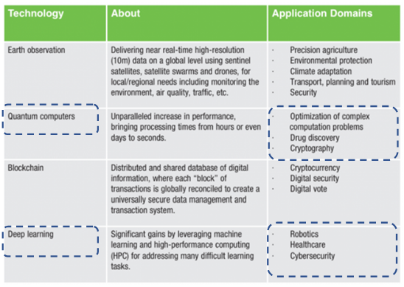

**6.5 CONCLUSION**

The automatic identification and information management system of the weapons management system is made possible by the implementation of RFID in the weapon and equipment management system. This system is able to provide a computerised platform for the inventory of military weapons and equipment going into and coming out of the armoury. It is able to access information regarding the automatic identification and acquisition of weapons, as well as records, uploads, and maintenance of weapons, in a manner that is effective, exact, and intelligent. In addition, provide information on how to quickly inquire about information, statistics, and management tools for weapons and equipment.

While high-performance computing has made it possible to use models based on physics in the design and manufacturing of exceedingly complex systems like military platforms, it has also made physics-based modelling more difficult to implement. As time goes on, supercomputing transforms from an extremely challenging, pricey, and limited instrument into one that, in the present day, brings high-performance computing power to the desktop and makes it accessible remotely over the internet. This emphasises that a programme of constant upgrades in equipment, software, and staff capability must be performed if one desires to be in a position of leadership in the field of material procurement. These updates can be applied to both hardware and software. This transition must be driven forward by management on all different levels.

Even though some militaries are a long way off from adopting supercomputers or even high-performance computing at this time, future development planning must be done in order to compete with other military organisations throughout the world. This is necessary in order for us to be able to leverage the benefits of high-performance computing and related systems in order to meet our requirements. With the implementation of all digital technology options, the hope of changing into trustworthy and reliable troops by updating their assets before the year 2050 will advance one step further.

**ACKNOWLEDGEMENT**

This work was funded by the Ministry of Higher Education of Malaysia under a Fundamental Research Grant (**PY/2021/02164).** We also thank the Malaysian Armed Forces (MAF) for scholarship funding for this Master's Degree study.

I wish to extend my deep sense of sincere gratitude to my lecturers, Associate Prof Dr Radziah Mohamad and Associate Prof Anazida Zainal. The school at large, Universiti Teknologi Malaysia, for providing me with the necessary skills, knowledge, and learning facilities to prepare this paper, and my fellow friends for their support and encouragement towards my academics.

**REFERENCES**

J.P. Lacroix, I. Nakamitsu (2018).

Effective Weapon and Ammunition Management. New York: Department of Peacekeeping Operations, United Nations.

L. Yuengert, D. Douds (2020).

How the Army Runs. Pennsylvania: U.S Army College. Hobbs, Wayne & Chalmers, Greg & Sivan, Dmitri & Davies, Phil. (2001). A METHODOLOGY FOR ANALYSIS OF AUSTRALIA'S FUTURE SOLDIER. Journal of Battlefield Technology. 4. 28-33.

Anand Lal Shimpi (2019).

Inside the Titan Supercomputer: 299K AMD x86 Cores and 18.6K NVIDIA GPUs. Anand Tech, October 31, 2012

Don Johnston (2014).

HPC Matters to Our Quality of Life and Prosperity. Scientific Computing, November 11, 2014

“High-Performance Computing for Manufacturing (HPC4Mfg) Accelerating Innovation,” Lawrence Livermore National Laboratory, accessed April 1, 2016

“Army Strategic Capability Development for the Next Generation (2021-2050)”.

Zeichick, Alan (2019).

Go Big, Really Big, As High-Performance Cloud Computing Scales to Millions of Jobs. Forbes, August 14, 2019.

Gartner Research (2018).

Top 5 Ways to Successfully Deliver HPC Cloud Strategies, November 29, 2018.

Morgan Eldred, Dr. Carl Adams, Dr. Alice Good (2014).

Trust Challenge in a High-Performance Cloud Computing Project”. IEEE 6 International Conference on Cloud Computing Technology & Science, 2014.

T.Groves (2016).

Characterizing and Improving Power And Performance of HPC Networks”, University of New Mexico and Sandia National Laboratories, 2016.