**CHAPTER**

**7**

**AMBIENT COMPUTING ADOPTION APPROACH FOR SMART WEAPON MANAGEMENT SYSTEM**

*Muhammad Shafie Hasulbullah and Dayang Norhayati Abang Jawawi*

* 1. **INTRODUCTION**

The Smart Weapon Management System is a forward-thinking method of operation that is going to be implemented in the armed forces. The ability of military officials to plan ahead, including the capability to pre-plan actions via the internet, is one of the desired outcomes of this approach, which aims to make use of the Internet of Military Things (IoMT). If all goes according to plan, military personnel who have been given authorization to enter the armoury will have finished the vast bulk of their work by the time they get there. When a tasking order to deploy is received, the commanding officer can utilise the system to verify the current status of his weapon and manage his subordinates in accordance with the current status of the weapon. This monitoring system is designed to keep tabs on firearms through the utilisation of software screens, bar codes, and Radio Frequency Identification (RFID) technology in order to ensure that firearms are properly accounted for at all times.

The software will be designed and customised to meet the particular requirements of the armed forces in any circumstance they may find themselves in. It is possible to easily adapt the programme to the language (data fields) that is preferred by each individual member of the armed forces. In addition to this, process can be automated, and reports can be generated in accordance with either the operational standards that are currently in place or those that are preferred.The Smart Weapon Management System has software components that, in addition to tracking weapons and equipment, keep tabs on the cleaning and inspection of weapons, as well as their maintenance and testing. Armory administrators utilise these solutions to enhance the flow of equipment, decrease inventory discrepancies, and ensure chain of custody. This ensures that only authorised individuals have access to the appropriate equipment. It is possible for management solutions for armouries to be adapted in order to fulfil the specific needs of any individual armoury. The equipment tag, which is used to scan and enter all inventory into the database, is one of the hardware components. Other components include a stationary unit, a mobile unit with a touch screen tablet, and a mobile unit. In addition to simplifying the process of checking out, contemporary technologies also assist reduce the likelihood that equipment may be misutilized. It is possible that some military training and operations may incorporate components for the management of armoury inventories. These components are analogous to evidence management software that is tailored specifically for physical evidence. To ensure that all security needs are satisfied, specialised systems for managing armouries are developed and implemented for military personnel.

It is possible to draw parallels between the implementation of IoMT and the civilian Internet of Things, which makes use of technology to gradually expand the capabilities of its network. The military armed forces are presented with a new working environment inside the armed forces as a result of the implementation of weaponry management systems such as the smart weapon management system. The smart weapon management system programme includes everyone in the military who participates in either operational or training actions. This includes both active and reserve soldiers. The implementation of a smart weapon management system has led to the inclusion of a variety of principles and ideals into the culture of the armed forces.

* + 1. **Creativity in the Use of New Technologies**

The armoury staff will be able to make better use of the technology, which is being developed specifically to assist them in performing their jobs more effectively. The implementation of a web-based smart weapon management system would completely eliminate the need for paper papers and usher in a new era of paperless company operations. This will cause a sea change in the manner in which companies do business. After 5G technology has been adopted and put into operation, the architecture of smart weapon management systems will be able to fully exploit all of the resources made available by the Ministry of Defense, such as MindefNet and Satellite X-band. This will be possible once 5G technology has been implemented.

* + 1. **Innovation for System Improvement**

A smart weapon management system will increase the performance of the weapon management system. Through the utilisation of web-based apps and RFID tags, man and machine are always linked and in the loop. In contrast to the former procedure, military personnel will now be able to log in and register in order to withdraw a weapon. In response to their request, the system will send them an email containing the date and time of the event. The system will deliver the date and time information based on the request. According to the IKEA warehouse model, military personnel will enter the armoury at a predetermined time and collect weapons from the racks without assistance from armoury workers or contractors.

The smart weapon management system provides the capability to track and search for weapon certifications, as well as the current status, and materials necessary for a post, while the transfer and return activities are being carried out. It is conceivable to adopt a single database for a smart weapon management system to model and track a wide variety of things. Included in these items are documents, evidence, and the present status of weaponry.

* + 1. **Suitable for a Decade of Use**

In addition to armoury workers and military personnel, this system offers the user-friendly application and management solutions. Users of the smart weapon management system will have no trouble adjusting to the online method once it is implemented if the current practise in the logistics department is adapted to the online approach. RFID tags are becoming more prevalent in today's society. Everything is possible with a concept adaption available for purchase at the Decathlon Store. When RFID is implemented on the majority of Malaysia's roadways, military personnel will become more acquainted with the technology. During their training, the military will teach them situational awareness to ensure that they remain on course while carrying out their armed tasks. Despite the fact that the system will be conducted online, it is not meant to violate existing military norms of conduct. This technology may in the future be linked to the Command-and-Control System in order to track blue forces. This can add value to the current system, which can increase the commander's decision-making efficiency by boosting the accessible possibilities.

* + 1. **Impact of the Implementation**

This technology is utilised by the programme to do various jobs for the armoury staff simultaneously. Each transaction, whether a weapon is withdrawn or returned, is recorded in the system, and the weapon's current status is automatically communicated to the relevant superior after the transaction has been completed. It enhances the responsiveness and productivity of individuals in the workplace, particularly with respect to time management. No longer are military personnel required to wait at the armoury. Military personnel can utilise this time to complete another duty or to help create a more convenient working environment for themselves and others.

* 1. **RELATED WORKS**
     1. **The Existing System**

An armoury is a secure location for storing weapons. It is the responsibility of the layer system to provide security. The armoury is located in a secure area, which offers the initial level of safety. Exterior doors and walls constitute the second security layer. The exterior door is secured with a security lock, and the windows have been barred to prevent unauthorised persons from getting access through them. You can add a third level of security to your system using key control. The key to the armoury should only be accessible to authorised personnel. The access control system constitutes the fourth protective layer. Only authorised employees with legitimate business are permitted to enter the armoury, and even then, only one individual at a time. This is accomplished with the employment of an armory-located access control cage. The fifth tier of protection prevents theft by securing the weapons to their racks with chains and padlocks. Finally, only unloaded firearms may be brought into and removed from the armoury. Therefore, the weapons cannot be used to injure the armoury staff, and if they are taken, they are rendered useless due to the lack of ammunition. Therefore, it is impossible for an organised crime group to instantly arm themselves after raiding an armoury in order to wreak more damage.

Weapon racks are designed to store firearms safely and securely. Individual weapons cannot be taken from the racks until the armoury personnel opens the rack's lock. The racks are constructed from wood and are designed to allow the weapons to stand upright while being secured. Individual weapons are typically stored in the rack's 25 slots per side. There are numbered weapon slots, and weapons must always be placed in the correct slot. Alternately, if no weapon is present, the corresponding weapon card should be present, stating that the rightful owner is in possession of the weapon for official purposes.

At least three layoffs are conducted with the magazine removed and the functional parts engaged. If any rounds were ejected during this procedure, they are retrieved and reloaded into the magazine. After the weapon has been unloaded, the safety catch is removed and the weapon is directed in a safe direction. After removing the safety catch, the action is unleashed. The safety catch is then applied again.

The working components are retracted and locked in place. If there is a "holding open catch," it is engaged. The staff member manually examines the chamber with his finger to guarantee that no round is there. He acknowledges that the firearm is unloaded by uttering the word "CLEAR" when he is certain. The individual will only allow the moving parts to proceed after receiving this directive from the armoury staff. The user then verifies twice that the weapon is pointed in a safe direction before pulling the trigger. The armoury personnel then takes possession of the weapon and, after confirming that it has the correct butt number, places it in the allotted rack. In the meantime, he removes the weapon card from his pocket and hands it to the owner of the weapon.

When an individual approaches and enters the armoury, the situation grows more dire. The military personnel issues the weapon card to the armoury employees. The armoury personnel examines the butt number before proceeding to the corresponding rack position. He selects a weapon and attaches its card to the designated spot. The individual is then presented with the weapon, and the armoury staff removes the operational components from the weapon's front slit. Holding them at the rear of the chamber enables the individual to confirm that there is no round present. When the individual says "CLEAR," the armoury staff releases the action and reapplies the safety catch to ensure that the weapon does not fire. Upon completion, the individual receives control of the weapon and exits the armoury.

* + 1. **The Proposed Future System**

The Smart Weapon Management System will be delivered to the military as part of the IoMT as one of the forthcoming smart soldier features. In order to assist them in protecting their weapons and equipment, the system streamlines the check-in and check-out procedures for all forms of inventory. These systems utilise an internet connection and the Internet of Things to digitally identify troops and manage tagged products, leading in the construction of a secure database that tracks who and when uses equipment. Using the daily reporting functions of the armoury management software, you can streamline auditing tasks by keeping track of all allocated equipment and detecting equipment that requires maintenance. Figure 7.1 illustrates the infrastructure and components that 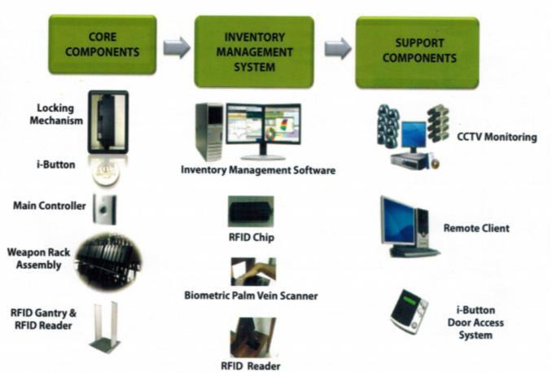powered the smart weapon management system.

Figure 7.1: Infrastructures in smart weapon management system

* 1. **AMBIENT COMPUTING**

Ambient computing, a type of computing that takes place in the actual environment, has emerged as a key advancement in computer-human interactions. Using the notion of ambient intelligence, computers are incorporated into our natural settings. Due of their environment-awareness and adaptability, they are more suited to give intelligent services to humans. Ambient computing, on the other hand, involves communication between a lot of incompatible heterogeneous components. Ambient computing is predicated on the premise that humans would utilise multiple computers implanted in their surroundings, allowing technology to slip into the background. The current era of computing is known as the ubiquitous computing era, and it is characterised by the explosion of small networked portable computer products such as smartphones and tablets, as well as embedded computers built into many of the devices that we own. This has resulted in a world in which each individual owns and uses a growing number of computers that are increasingly integrated into daily life. Figure 7.2. demonstrates that communications extend beyond the usual notions of man-to-man or man-to-machine connection to encompass direct interaction between machines.

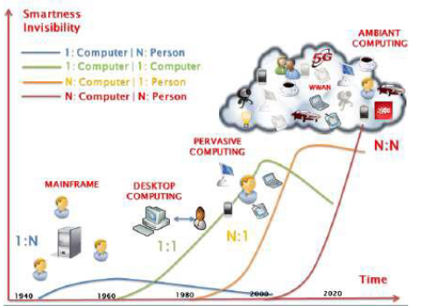**Figure 7.2**: Evolution of computers, from the beginning to the ambient computing.

Ambient computing, a type of computing that takes place in the actual environment, has emerged as a key advancement in computer-human interactions. Using the notion of ambient intelligence, computers are incorporated into our natural settings. Due to their environment-awareness and adaptability, they are more suited to give intelligent services to humans. Ambient computing, on the other hand, involves communication between a lot of incompatible heterogeneous components. Ambient computing is predicated on the premise that humans would utilise multiple computers implanted in their surroundings, allowing technology to slip into the background.

* + 1. **Ambient Computing in Military Sector**

In the twenty-first century, warfare has developed into a digitalized cooperative union approach that is mostly dependent on the system's ability to supply real-time information. This shift in strategy was brought about by advancements in technology. During the entirety of the battle, vital information is passed back and forth, from sensing to firing. As a direct consequence of this, a paradigm shift is necessary in the areas of observation, reconnaissance (ISR), command and control (C4I), and precision strike (PGM). The application of network and ambient computing technologies to national security in the twenty-first century is essential for the conduct of many different types of conflict.

* + 1. **RFID as a Logistics Support Tool**

An essential characteristic of RFID technology is its capacity to deliver logistical support in any and all locations. As a component of the all-encompassing logistic support, a wide variety of weapon system's real-time processing will be placed without the participation of people. These procedures will comprise identification, verification of position, and status checks including damage assessment and measurement, route tracking, and other similar procedures. Information regarding supplies that are appropriate for war situations, requests for supplies, repair systems, and the search for the most effective supply route are all available in real time and may be accessed in this manner. Additionally, real-time processing of priority supply requests is possible at the headquarters, within militant units, and within logistic support units.

The constant supply of logistical assistance will have a significant impact from the perspective of centralised war management. Attaching sensing-equipped wireless recognition tags and chips, data management, data storage, and communications capabilities to all military systems and equipment will facilitate the formation of ad hoc networks between them. These networks would be interconnected with future networks for military communications, including the satellite military communications system and the TICN system.

RFID will utilise radio frequency to validate materials, persons entry (or transfer), and position. This technology will also be utilised to identify categories. It is necessary to incorporate a reader, a transponder, and a computer or other data-processing device into an RFID system for the system to perform as intended. Electrical circuits within the RFID reader transmit and receive frequency from and to the transponder (or to tags), respectively (or to tags). The central processing unit (CPU) of the reader will encrypt signals that are transmitted by the tags, validate the data signals, store this information in memory devices, and transfer it as required. A radio antenna, capable of both transmission and receiving of signals, is built inside the reader. Either a direct connection to the circuit board or an enclosure within the private case are both possible for an antenna.

Chips in the integrated circuit that have been custom-built play an important part in the tag and are responsible for managing communication between the tag and the reader. The data storage device on the chip is broken up into multiple different sections. A location for storing certification numbers and other types of data, as well as a second location for receiving and transferring information regarding signal-activating tags from the reader. To synchronise the frequencies of the tag's antenna with those of the chip's antenna, a capacitor is put inside the tag. Memory devices for storing data at each address are often included in tags. Tag memory capacity can range anywhere from 8 bits to 16 KB. The majority of RFID systems are "customised," meaning that each one is given its own frequency as well as its own antenna size. This is done to ensure that the systems perform as intended. The signals that are transmitted by the antenna from the reader fall within the acceptable signal range.

The information that is stored on the tag will begin to be sent to the reader as soon as the tag detects the reader's signal and is within range of the antenna of the reader. This happens when the tag moves through the signal range of the antenna. In general, the frequency transmissions from the reader to the tags carry time information and deliver an adequate amount of electric force to activate the tag. When data is transmitted from the tags to the reader, the reader first transforms the data into digital signals and then uses CRC checks to validate the data and ensure its authenticity.

In general, tags can be divided into two categories: active and passive. For active kinds, batteries are a need. It receives electricity from either devices that are attached to the tag's non-metallic case or from batteries that are attached to the tag. These types have the advantages of using less power from the reader and allowing signal detection to be extended further away from the reader than is possible with other types. The battery life is the limiting factor in the amount of time that the active version can be used, it can only be utilised in optimal settings, and the cost of the active version is more than the cost of the passive version. Tags of the passive type can be powered either by their own internal or external power sources or by the electric impulses produced by the reader. Active tags are heavier and more expensive than passive tags, although passive tags can be used in a semi-permanent way and are less expensive overall. On the other hand, passive tags have the drawback of having a shorter recognition distance and needing more reader power loads than active tags do.

These tags are able to be divided into three distinct categories on the basis of the functionality they provide. Reading and writing are the first steps. Second, you should only write something down once and read a lot. Thirdly, you should only make use of read-only type. Both passive and active forms of tags can be constructed using the aforementioned forms of tags. The features of status check and position detection offered by the RFID ubiquitous network can be utilised to their full potential in the distribution and retail sectors. When RFID tags are applied to products (or packaging, transportation, or fork lifts, etc.), it is possible to perform efficient tracking of the product's position, stock management, and automated transactions.

Utilizing a chip allows for the management of all military weapons, vehicles, military installations, supplies, and ammunitions throughout their entire lifecycles. This includes the manufacture stage, supply stage, transit stage, stock management stage, maintenance management stage, and disposal stage. Which means that the RFID-enabled military supplies can be connected to information about delivery routes in order to determine the most effective method for delivery to supply units, and supply units can identify the required supplies for each consuming unit in order to better plan for future supply delivery. Through the communication that takes place between the RFID chip and the information system, it is possible to manage an adequate level of supply without having to rely on man hours.

Additionally, logistical support supplies would be attached to the repair system throughout its expected lifetime. Using information about the equipment's location and condition, weapon system and usage frequency estimates will be done in real time. By dispatching maintenance support units promptly when required, the equipment's performance will be enhanced.

The deployment of an RFID-based, all-encompassing logistic supply system allows for the management of all logistic supply networks, improves supply cycle efficiency from supply quarter to troops, and fortifies supply organs through the effective management of information among military supply management units, supply units, and corporations.

* + 1. **Smart Weapon Management System** **Applies Ambient Computing**

The smart weapon management system has been perfected to approach the idea of ambient computing in a way that is optimised for accounting for weapons. The idea is to keep track of weapons, gear, and defensive equipment through the utilisation of software screens, bar code technology, and RFID technology. The software is regarded to be Commercial Off-The-Shelf (COTS) software, which indicates that it has been completely developed but can still be modified to match the specific needs of each customer. The smart weapon management system not only keeps tabs on weapons and other equipment, but it also includes software components that keep tabs on the cleaning, inspection, and maintenance of weapons, as well as test firings and other related activities.

***7.3.4.1 The Software for Management System***

The software is compatible with both Windows and Linux operating systems, and it can be used either as a hosted service or it can be installed on a local server or servers. The smart weapon management system was developed to be expandable in order to manage an unlimited number of users, locations, and data. Software and Hardware for Bar Code Scanning and Tracking Screens for tracking weapons and equipment are a part of smart weapon management systems. These screens allow staff members to enter information using a keyboard or bar code or RFID tag affixed to an item scanning for the purposes of tracking and reporting. The software is compatible with both Windows and Linux operating systems, and it can be used either as a hosted service or it can be installed on a local server or servers. The smart weapon management system was developed to be expandable in order to manage an unlimited number of users, locations, and data. Software and Hardware for Bar Code Scanning and Tracking Screens for tracking weapons and equipment are a part of smart weapon management systems. These screens allow staff members to enter information using a keyboard or a bar code or RFID tag affixed to an item scanning for the purposes of tracking and reporting.

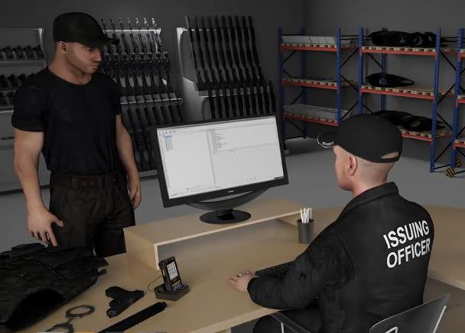

**Figure 7.3:** The concept of ambient computing alleviates the workload of armoury staff

The smart weapon management system delivers robust performance and tracking capabilities at a cheap cost by utilising software displays and scanning devices that are connected through USB. This system also requires very little additional investment, if any at all. RFID technology is now the most advanced technology available for use in the field of weapon tracking. The system functions by affixing one-of-a-kind RFID tags to various pieces of equipment, including firearms. It is possible to link the item serial number or weapon serial number that is stored in the database to the RFID tag. The database for the weapon transaction log is illustrated in figure 7.4.

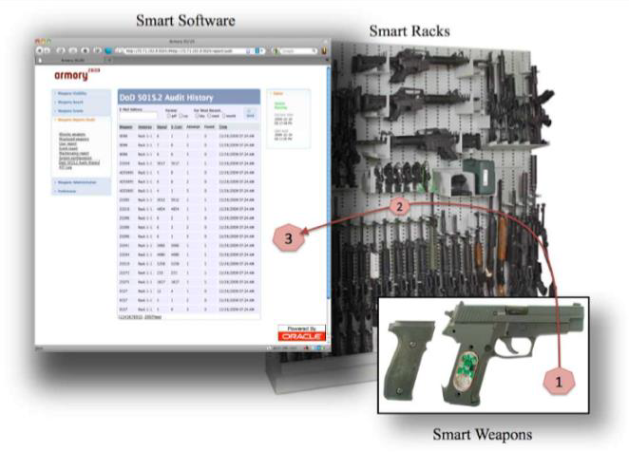

**Figure 7.4:** All the transactions will log into database

***7.3.4.2 Identification of Armory Staff***

The personnel working at the Armory can also be identified using RFID technology by donning RFID name badges, which have been distributed to each authorised member of staff. Radio waves that are released by RFID antennas that are positioned around doorways and/or issue windows will be saturating pass-through zones when people and items move through pass-through zones, allowing for the passive detection of each person and item as they move through pass-through zones. RFID antennas are positioned around doorways and/or issue windows in the Armory. These antennas will detect in a non-active manner each person and item that passes through the Armory. In order to decide which motion sensor will be activated first, motion sensors are placed on either side of the entryway or window to establish directionality. This allows for the determination of which sensor will be activated first (Issue or Return). As a result of the motion caused by the sensors, the RFID technology is activated as well, and its antennae are able to track who or what is going into and coming out of the armoury.

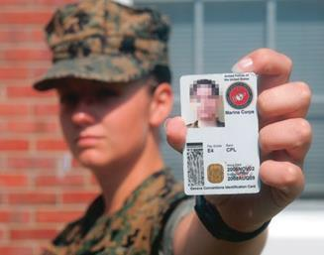

**Figure 7.5:** RFID embedded in the ID Pass

* + - 1. ***The System Component***

The database of the smart weapon management system is given an update that includes the RFID data for the item, person, and read-zone position. Additionally, the transaction is noted along with the time and date that it was completed. When RFID technologies are in place, flashing light stacks and a smart weapon management system can be utilised to trigger events in accordance with the requirements of the business (unauthorized access, unauthorised removal, failure to return an item.). After a shift change or whenever it is judged necessary, portable RFID scanners are frequently utilised for the purpose of quickly inventorying weapons and other types of equipment. The information that is collected is then uploaded to a database, where it is used to do a variety of activities, including automatically generating inventory reports and inventory exceptions reports. Additionally, it is possible to use portable scanners in order to inventory objects that have been distributed to posts or other locations that are not armory-related. In addition, portable RFID scanners enable users to locate specific items or items that have been misplaced by functioning in a manner analogous to that of a metal detector and pointing users in the direction of the location of a certain object. The software that controls the smart weapon management system is stored on a file server. As can be seen in Figure 7.6, RFID antennas or sensors are set around the doorway(s) for in-and-out tracking, and an RFID reader is installed on the weapons racks so that quick inventory can be performed. This allows for efficient storage of the weapons.

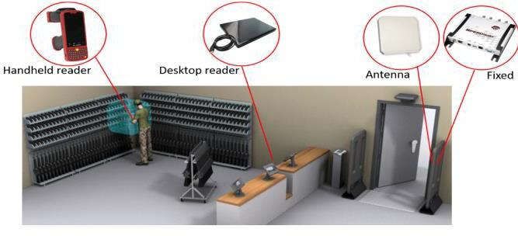

**Figure 7.6**: Component in smart weapon management system

* + - 1. ***RFID Doorway and Issue Window for Issue / Return Tracking***

At the facility housing the armoury, RFID transmitters are installed around the doorways or issue windows in order to keep track of the weapons and equipment. The directionality of an issued or returned weapon can be determined by using proximity sensors. RFID tags can be attached to or placed in various pieces of equipment and weaponry, and workers may be given RFID name cards.

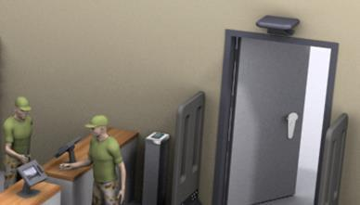

**Figure 7.7:** RFID Doorway and Issue Window

The database is updated with the person's information as well as the items they took out of the armoury or put back in it whenever someone enters or leaves the facility. When items are returned to the armoury, electronic signatures can be obtained either from the person who removed or issued the item, or from a member of the armoury staff. The chain-of-custody logs, in which the signature is recorded, can be printed out to display all signatures confirming weapon and gear transfers as proof of custody. It is possible to put alarm and flashing light methods in the armoury. These mechanisms are activated when certain company standards are violated, such as when an item is removed illegally or when an employee forgets to return an item after a shift change, among other violations. Cabinets are made available to contain the reader and the related wire, and they can also be used to attach the light stack or alarm.

* + - 1. ***Portable RFID Scanner for Inventories***

Portable RFID scanners have various benefits, including the capacity to conduct rapid inventories and the ability to discover things that have been misplaced or that are required. The scanner sends out radio waves that can identify objects up to 20 feet away. This enables a speedy inventory of all of the weapons and gear that are stored in the armoury, and it also allows the position of the items in the database to be updated to read "in armoury." If a user realises that an item is missing, they can input the item's serial number into the scanner. Once the item is located, the scanner will beep either more quickly or more slowly depending on how close it is to the user, leading them directly to the missing item. The scanner also supports bar codes, which means that bar codes may be placed on shelves, containers, and other surfaces, and the specific location of goods that are to be stored can be established using this information. Bar codes can be found here (through bar code scanning).

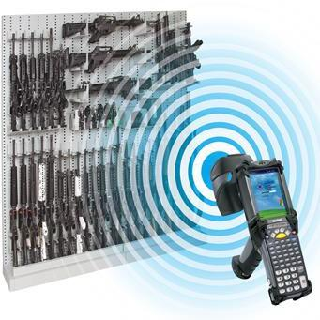**Figure 7.8:** Using RFID Scanner to record into inventory system

* + - 1. ***Placing Tags on Weapons***

Tags for weapons can be a wide variety of shapes and sizes, and they can be attached to a wide variety of places. There are tags that have been purpose-built specifically for placement on composite surfaces and/or metal surfaces, and these tags can be found. Epoxy with strong bonding qualities is typically used to attach tags to grips. This helps to ensure that tags remain in place even under the most difficult of circumstances. The Weapons/Gear tags and epoxy are resistant to weapon firings, vibration, extreme heat and cold, water, cleaning solvents, and ultrasonics, in addition to being resistant to routine weapon usage and cleaning procedures. When it comes to handguns, the best results are typically gained by embedding a small RFID tag inside the weapon handle or cavity. This ensures that the tag does not block the slide in or out of the magazine in any way. When it comes to long arms, the tag should typically be put either within the grip or along the outer surface of the underbelly of the weapon. A tag location is shown in Figure 7.9 for illustration purposes.

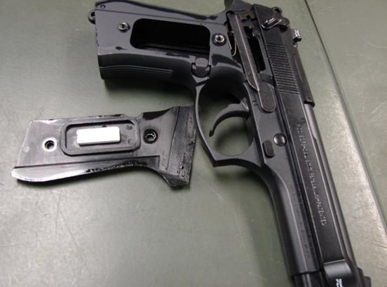

**Figure 7.9:** Tag Placement on Weapon

* + - 1. ***Adding a Weapon to the Database***

The data entry screen for each armoury facility is individualised such that it contains only the fields that are important to that facility. You have the option of using a keyboard, a drop-down list of values, a Yes/No check box, a pop-up calendar, or scanning bar codes or RFID tags and inputting the information that way instead of filling out each field manually. In order to reduce the likelihood of data entering mistakes, serial numbers are frequently required to be entered twice. There is also the option to include a note, and the content of the note itself, in addition to the other fields, is searchable.

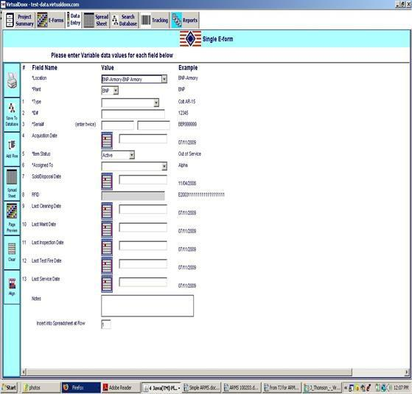**Figure 7.10:** The data entry application’s screen

* + - 1. ***Electronic Forms & Report Formats***

Smart weapon management system has the capability to scan or design electronic forms into the application, and data entry panels model the data entered when scanning or designing the form. It is possible to scan/digitize printed forms with handwritten additions and display them on computer screens once they have been attached to the correct database record and scanned/digitized. In addition, report data can be formatted into electronic form types that are compatible with existing report formats, or it can be adapted to match any desired report forms.

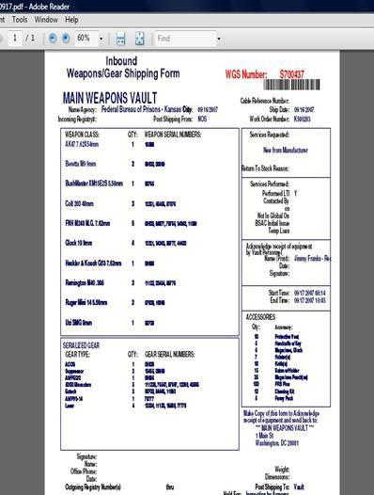**Figure 7.11**: Electronic Forms and Report Format

* + - 1. ***Report***

A thorough reporting subsystem is included in a smart weapon management system. This subsystem does direct database searches on all items, all things that are "out," inspection/cleaning/test firing histories, inventory reports, and inventory exceptions reports. The smart weapon management system offers standard as well as customizable report options, and the data can be viewed in .csv, .html, or other spreadsheet formats.

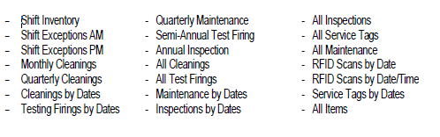

Figure 7.12: Standard Reports

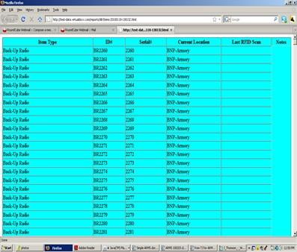

**Figure 7.13:** Direct Database Queries

The adoption of RFID as one of the components in smart weapon management systems has facilitated the introduction of a new way of operating in the armed services. It takes over several jobs that a human should be able to accomplish without the need for additional training because it scans and logs information into a database. This will make it possible to make use of the ambient computing that has become ingrained in the new standard operating procedure in the armed forces.

* 1. **RESULT AND DISCUSSION**

A new technology that unexpectedly replaces an older one is referred to as "disruptive technology," which is a word that has been taught. There are two distinct groups comprised of newcomers. There were two different kinds of technology that were suggested, and those were sustaining technology and disruptive technology. It is necessary to make small but steady improvements to an existing technology in order to maintain it. These improvements might take the form of system upgrades or enhancements to technology that is already in use. On the other hand, disruptive technology is imprecise and frequently lacks performance due to the fact that it is novel, attracts to a small audience, and may not yet have a demonstrated practical application. These factors contribute to the fact that disruptive technology is less likely to be successful. Many times, disruptive technologies are associated with a rapid rate of technological progress, a wide potential scope of impact, a substantial financial impact economic value that could be impacted, and a large risk for economic disruption. This is because disruptive technologies tend to have all three of these characteristics.

It is one of the most crucial features of disruptive technology to be able to offer customers brand-new and significant benefits, as this is one of the most important aspects of disruptive technology. When a technology of this kind is finally made available to consumers, there is the possibility that it will cause a paradigm shift throughout the entire sector. The internet has largely replaced more conventional ways of gathering information, and as a result, it has had an impact not only on libraries and newspapers, but also on social connections. Individuals are now able to conduct their own investigations in a different manner as a result of this shift. Individuals as well as companies can profit from disruptive technology if they adopt it into their day-to-day operations and make the most of the opportunities it offers.

The IoTs are built on a foundation of minuscule sensors that can collect data and send it off to servers or the cloud in an automated fashion. It would then be possible to immediately develop usable charts and dashboards, which would provide deeper insights and real-time feedback, so enabling decisions to be made more quickly and with more accuracy. In the Internet of Things, a node can be considered anything that has a sensor attached to it. Sensors are able to capture and/or send data on a wide range of variables, including location, altitude, velocity, motion, temperature, humidity, illumination, blood sugar, air quality, and soil moisture, amongst others. They are not computers in the traditional sense; rather, they are pieces of hardware that record particular conditions and send and receive information relevant to those conditions over the Internet. The fundamental architecture of the Internet of Things can be supported in an effective manner by a variety of network designs. Technologies for short-range local area networks, such as RFID, are included in the category of local area communications. This infrastructure will also be contributed to on a mobile and microscopic level by local scanning devices in a restricted area that are composed of short-range sensors. These gadgets are not dependent on any particular network but rather rely on being scanned locally, much like RFID tags.

The IoTs platform is a multi-layered piece of technology that enables connected devices to be managed and automated. To put it another way, it is a service that makes it possible to save physical items in an online repository. This platform will enable machines to communicate with one another by connecting various devices. It is a technology that connects edge devices, access points, and data networks to the other end, which is often an end-user application. This technology belongs to the category of software-defined networking. To use the smart weapon management system, members of the armed forces need to first connect to a protected network before they can make a request for further information on their existing weapon, remove it from service, or hand it back in. There are two types of encrypted connections that are made available to members of the armed services. These include MindefNet and Satellite X-band. With the Internet of Things (IoT) integrated into this private network, the system will be able to function in a manner that is compliant with the rules and guidelines established by the military. With the help of the combination of these game-changing technologies, the idea of ambient computing may be put into practice.

The architecture of the IoT system is depicted in figure 4.1. The first step is to acquire the necessary information and transform it into something relevant. The second step entails transforming the data from its original analogue format into its equivalent digital representation. Additional data analysis is carried out by the information technology system of the smart weapon management system in the third stage. In the fourth stage, the data that must be processed further but can wait until later will be moved to the data centre.

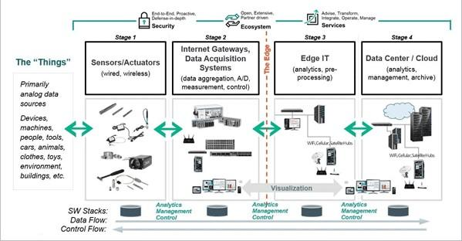

Figure 7.14: The IoT Solutions Architecture

**7.5 CONCLUSION**

The field of ambient computing focuses on using directed evolution as a method of providing assistance to various military systems, most notably weapon management systems. This will cover every component of the system, from the hardware to the software, as well as the user experience and the interface between humans and machines. We have seen developments that point to a future abundant with this kind of technology, but in the future, we won't be constantly harassed and annoyed by personal devices. Instead of that, ambient computing will make all technology disappear and blend into the background, eliminating the need for us to see it running and making it impossible for us to become distracted by it. This results in an increase in the value of military assets and manpower, which in turn enables a reduction in the capacity of military facilities. Additionally, the workforce at that particular workplace might be reduced, which makes it possible for employees to be repositioned to more appropriate roles. It will operate in a way that is both unobtrusive and unobtrusive, so as to be of assistance to us in our day-to-day lives. Computing in the ambient environment is not only the way of the future for intelligent bases, but it will also usher in a new era of intelligent conflict. Computing in the ambient environment is the wave of the future in terms of technology, and its potential application in the military is very interesting.

**ACKNOWLEDGEMENT**

The authors fully acknowledge Universiti Teknologi Malaysia assistance via UTM-HR Grant Vote No. 08G67 which has made this research possible. We also thank to the Malaysian Armed Forces (MAF) for scholarship funding of this Master's Degree study

**REFERENCES**

Couderc, P. et al. (2015).

Ambient computing applications: an experience with the SPREAD approach. 36th Annual Hawaii International Conference on System Sciences. Proceedings of the, 2003, pp. 9 pp.-, doi: 10.1109/HICSS.2003.1174830.

Gupta, A. *et al.* (2015).

Tele health therapy: An ambient technology. Global Conference on Communication Technologies (GCCT). pp. 749-754, doi: 10.1109/GCCT.2015.7342764.

Hobbs. et al. (2001).

A Methodology for Analysis of Australia's Future Soldier. Journal of Battlefield Technology. 4. 28-33.23.

Kanagarajan, S. *et al*. (2015).

Development of ontologies for modelling user behaviour in Ambient Intelligence environment. IEEE International Conference on Computational Intelligence and Computing Research (ICCIC), 2015, pp. 1-6, doi: 10.1109/ICCIC.2015.7435736.

Khalfi, M. et al. (2014).

A Framework for Ambient Computing. CLOSER - Proceedings of the 4th International Conference on Cloud Computing and Services Science.

Lacroix, J. et al. (2018)*.*

Effective Weapon and Ammunition Management. New York: Department of Peacekeeping Operations, United Nation.

Murthy, V. et al. (2015).

In silico Consciousness: The Goal of Ambient Intelligent Computing. Symposia and Workshops on Ubiquitous, Autonomic and Trusted Computing, pp. 411-416, doi: 10.1109/UIC-ATC.2009.7.

Murthy, D. et al. (2015).

Internet of Things (IoT): Is IoT a Disruptive Technology or a Disruptive Business Model? Indian Journal of Marketing. 45. 18-27. 10.17010/ij/v45/i8/79915.

Rouillard, J. *et al.* (2010)*.*

Facilitating the Design of Multi-channel Interfaces for Ambient Computing. Third International Conference on Advances in Computer-Human Interactions. pp. 95-100, doi: 10.1109/ACHI.2010.30

Ungurean, I. et al. (2017).

An Internet of Things Framework for Remote Monitoring of the HealthCare Parameters. Advances in Electrical and Computer Engineering. 17. 11-16. 10.4316/AECE.2017.02002.

Yuengert, L. et al. (2020).

How the Army Runs. Pennsylvania: U.S Army College.